# Year 12 Physics Notes (Modules 5-8)

## By Alex Gray

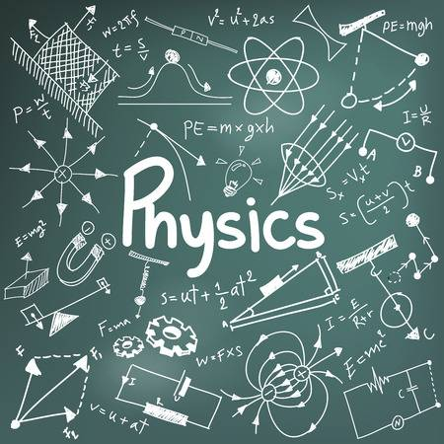

Contents

Advanced Mechanics 7

Base Units 7

Constants 7

Equations 7

Projectile Motion Equations 9

Using the Projectile Motion Equations 10

Question: 10

Algebraic Answers 11

Numerical Answers 13

Course Notes 14

Converting Degrees to Radians to Degrees 14

RPM to Radians per Second 14

Torque Equilibrium Questions 14

Banked Curves 14

Tension as Centripetal Force 15

Static Friction around a Corner 15

Change in Potential Energy in a Gravitational Field 15

Harder Potential Energy Concepts 15

Orbital Motion in a Gravitational Field 16

Geostationary Satellites 16

Kepler’s Laws 16

1st Law 16

2nd Law 16

3rd Law 16

Formula Derivations 17

Kepler’s Third Law 17

Escape Velocity 17

Velocity of a Satellite 17

Total Energy of an orbiting Object 18

Electromagnetism 19

Base Units 19

Constants 19

Equations 19

Electrostatics 19

Circuits 20

Magnetism 21

Electromagnetism 22

Transformers 22

Course Notes 23

Charges Moving in an Electric Field 23

Voltage 23

The Magnetic Field 23

Charges Moving in a Magnetic Field 23

Flux 24

The Area Vector ($\overset{⃑}{A}$) 24

Induction 24

Why does this effect exist? 25

A Note on the Difference Between Relative Motion and Changing Flux 25

Electromagnetic Beaks 26

The Motor Effect 27

Deriving the Motor Effect 27

Motors 27

DC Motors 27

AC Induction Motors 29

Generators 30

DC Generators 30

AC Generators 30

Transformers 31

Laminations 31

The Nature of Light 32

Base Units 32

Constants 32

Equations 32

Extension Equations 33

Course Notes 34

Attempts to Measure the Speed of Light 34

Galileo 34

Romer 34

Fizeau 35

Michelson 36

The Hertz Experiment 37

Waves need a medium – so what about light? 38

Absolute Space and Time 38

The Luminiferous Aether 38

Michelson-Morley Experiment 39

The Actual Medium for Light 39

Diffraction 40

Double Slit 40

Formulae: 40

Derivation of Formulae 41

Single Slit 42

Formulae: 42

The Quantum Nature of Light 43

Blackbody Radiation 43

The Ultraviolet Catastrophe 43

The Mechanism for Blackbody radiation 43

The Photoelectric Effect 44

The Work Function $ϕ$ 44

The Experimental Setup 44

Polarisation 45

Wave Model – Derivation of Malus’ Law 45

Quantum Model 46

Light has Momentum? 47

Relativity 48

Base Units 48

Constants 48

Equations 48

Galilean / Newtonian Relativity 48

Einsteinian / Special Relativity 48

Course Notes 49

Inertial Reference Frames 49

Non-Inertial Reference Frames 49

Einstein’s Postulates 50

1) The Laws of Physics 50

2) The Speed of Light 50

Events in Relativity 50

The Lorentz Factor 50

Two things to remember 50

An Introduction to Special Relativity 51

Time Dilation 52

Why does Time Dilation Occur? – The Photon Clock 52

Length Contraction 54

Why does Length Contraction Occur? 54

The Momentum Equation and the Universal Speed Limit 54

Experimental Verification for Special Relativity 55

The Hafele-Keating Experiment - 1972 55

Muons from the Sun 55

Particle Accelerators 55

From the Universe to the Atom 56

Base Units 56

Constants 56

Equations 56

Extension Equations 58

Course Notes 59

Models of The Atom 59

Dalton – 1808 59

Thomson – 1904 59

The Cathode Ray Experiment 60

Millikan Oil Drop Experiment – 1909 60

Rutherford – 1911 61

Bohr – 1913 61

Theorisation of the Proton and Neutron – 1920s 62

De Broglie – 1924 62

Schrödinger – 1926 62

But isn’t wave motion accelerated motion? 62

Chadwick – 1932 63

The Neutron Experiment 63

The Standard Model 64

Terminology 64

What is the Standard Model? 65

Anti-Particles 65

What does $E=mc^{2}$ mean? 66

Conservation Laws 67

The LHC and other Evidence for the Standard Model 68

Quarks, Gluons & Colour Charge 69

Nuclear Physics 70

Terminology 70

Decay 71

Alpha $α$ Decay 71

Beta $β$ Decay 71

Gamma $γ$ Emission 72

Penetrating Distance and Ionisation 72

Half Life 73

Fission 74

The Moderator 74

Control Rods 74

Enrichment 74

Fusion 75

Getting Energy from Fusion 75

Forces, Energies and Emitted Particles 76

Mass Defect in Stars 76

Fusion Inside a Star – Hydrogen to Helium and the CNO Cycle 77

Spectral Classes 78

Star spectra and what it says about a star 79

What can it the absorption spectra tell us? 79

The Big Bang and the Origins of the Elements 80

Timeline of the Big Bang 81

Inflation 81

The Cosmic Microwave Background and Cosmological Redshift 82

The Hubble Constant and Spatial Expansion 82

Proof for Spatial Expansion 83

Absorption Spectra as described by Atomic Theory 83

Accelerating Spatial Expansion 83

The Hertzsprung-Russel (H-R) diagram 84

# Advanced Mechanics

## Base Units

Mass ($m$) – Kilograms ($kg$)

Displacement ($\overset{⃑}{s}$) – metres ($m$)

Time ($t$) – Seconds ($s$)

Speed ($v$) – Metres per second ( $ms^{-1}$**or $m/s$**)

Velocity ($\overset{⃑}{v}$) – Metres per second ( $ms^{-1}$**or $m/s$** )

Acceleration ($\overset{⃑}{a}$) – ( $ms^{-2}$**or $m/s^{2}$** )Force ($\overset{⃑}{F}$) – Newtons ($N$)

Energy ($E$) – Joules ($J$)  
Work ($W$) – Newton Meters ($Nm$) **or**Joules ($J$)

Angular Displacement ($θ$) – Radians ($rad$)

Angular Velocity ($ω$) – Radians per second ($rad s^{-1}$)

Angular Acceleration ($α$) – Radians per second per second ($rad s^{-2}$)

## Constants

Gravitational Constant: $G=6.67×{10}^{-11}$ ($N m^{2} kg^{-2}$)  
Mass of the Earth: $m_{E}=6.0×{10}^{24}$ ($kg$)  
Radius of the Earth: $r_{E}=6.371×{10}^{6}$ ($m$)

## Equations

$${\overset{⃑}{F}}_{net}=m\overset{⃑}{a}$$

*Newtons is a measure of Force; One Newton is equivalent to one: kilogram metres-per-second-per-second (kg ms-2). The net means sum of all forces which accounts for the fact that there can be forces on an object but if they cancel there is no acceleration.*

$$F_{c}=\frac{mv^{2}}{r}$$

$$a_{c}=\frac{v^{2}}{r}$$

*Centripetal force or acceleration on an object derived from circular motion. Centripetal force is the description of the sum of forces on an object in circular motion. The actual force is often generated by tension in a string or a gravitational field.*

$$θ=\frac{l}{r}$$

$$ω=\frac{∆θ}{t}=\frac{v_{⊥}}{r}$$

$$α=\frac{∆ω}{t}=\frac{a_{⊥}}{r}$$

*Angular equivalents of linear factors. Equations for angular displacement, angular velocity and angular acceleration for an object spinning in a circle. Measured in* ***radians****,* ***radians*** *per second and* ***radians*** *per second per second.*

$$\overset{⃑}{τ}=\overset{⃑}{r}×\overset{⃑}{F}={\overset{⃑}{r}}_{⊥}\overset{⃑}{F}=rF\sin{θ}$$

*Torque on a rotating object is the Force on that object multiplied by the radius from the axis of rotation multiplied by sine of the angle between them.*

$$F_{G}=G\frac{m_{1}m_{2}}{r^{2}}$$

$$a_{G}=G\frac{m_{1}}{r^{2}}$$

*Gravitational Force between two objects of mass at some radius. G is the gravitational constant.*

*The acceleration due to gravity is dependent on the mass of the object generating the field.*

$$v=\frac{2πr}{T}$$

*Kepler’s second law of planetary motion. It states the average speed of a planet in motion is proportional to its radius divided by the time for one orbit around the sun.*

$$\frac{r^{3}}{T^{2}}=\frac{GM}{4π^{2}}$$

*Kepler’s third law of planetary motion. The relationship between radius and period of orbit with a constant (where M is the mass of the object it orbits).*

$$v_{esc}=\sqrt{\frac{2GM}{r}}$$

*Escape velocity of an object with mass at an initial distance, $r$, away. It is the minimum velocity an object must have to escape the gravity of that object.*

$$U_{G}=-\frac{Gm_{1}m_{2}}{r}$$

*The potential energy due to gravity of an object in another objects gravitational field. Note that it is not necessarily the total potential energy, but often is.*

### Projectile Motion Equations

$$\overset{⃑}{s}=\frac{\overset{⃑}{a}}{2}t^{2}+{\overset{⃑}{v}}_{i}t+{\overset{⃑}{s}}_{i}$$

*The displacement of an object in a given direction is given by this equation, where the displacement, acceleration and initial velocity are all vector components in the same direction. i.e. If the displacement is the displacement in the x direction, then the acceleration is the acceleration in the x-direction. It is possible for this to be zero.*

*The extra term ${\overset{⃑}{s}}_{i}$ on the end is the initial displacement from the target. E.g. if a ball falls from a table, its initial y-displacement from the floor is the height (if positive direction is up).*

*Note that it is a quadratic in terms of $t$.*

*The velocity of an object is given by the acceleration in that direction and the initial velocity in that direction.*

$$\overset{⃑}{v}=\overset{⃑}{a}t+{\overset{⃑}{v}}_{i}$$

$$v^{2}={v_{i}}^{2}+2as$$

*A rearrangement of the above formulae. Useful when time is not given.*

## Using the Projectile Motion Equations

$$θ$$

$$u$$

$$h_{R}$$

$$h_{T}$$

$$s_{x}$$

The below is intended to work through the problem algebraically with explanations such that you can try to solve it yourself. Numerical solutions are provided however working through the problem without numbers first is encouraged first.

### Question:

A ball is rolled up a slope off a table with initial velocity $v$ at angle $θ$ from the vertical.

1. How long does it take the ball to hit the ground?
2. How far is it from the edge of the table when it hits the ground?
3. What is the ball’s velocity when it hits the ground?
4. What is the ball’s displacement from the edge of the table when it is at the highest point of its arc? (Extension Question)

Solve the above problems if:

$$u=15ms^{-1} \\ θ=30° \\ h_{T}=1.2m \\ h_{R}=0.24m$$

*Next 3 pages for algebraic and numerical answers* .

### Algebraic Answers

1. To solve this first question, we need to construct an equation that solves for when the height of the ball is the height of the floor, which we are going to define as when $s_{y}=0$. We are also going to define up as positive.

On the formula sheet, the equation for displacement is $s=ut+\frac{1}{2}at^{2}$. Although this formula is good, it has an issue. When $t=0$, displacement is also zero ($s=0$) but at $t=0$ the height of the ball is $h_{T}+h_{R}$ which means our equation is slightly wrong. We can fix this by using the equation detailed above in the notes: $y=\frac{a_{y}}{2}t^{2}+u_{y}t+y_{i}$ where $y_{i}=h_{T}+h_{R}$.

Now we have a displacement equation in the y-direction, we need to find the initial velocity and acceleration in the y-direction. Using trig rules, $u_{y}=u\sin{θ}$. Acceleration is just gravity which can be defined as $g=-9.8$ ( $-$ because up is $+$).

Now to find $t$, we need to use the quadratic formula:

$$t=\frac{-u_{y}±\sqrt{{\left(u_{y}\right)}^{2}-4\left(\frac{g}{2}\right)\left(y_{i}\right)}}{2\left(\frac{g}{2}\right)}$$

1. To find the horizontal distance from the table ( $s_{x}$ in the diagram) we take the time taken to hit the ground and multiply it by the initial horizontal velocity. This can be derived from the displacement formula $x=\frac{a_{x}}{2}t^{2}+u_{x}t+x_{i}$ where $a_{x}=0, x_{i}=0$. $$∴s_{x}=u_{x}t$$

$u_{x}$ is given by the horizontal component of the initial velocity, i.e. $u_{x}=u\cos{θ}$

1. To find the final velocity, we have to add the two velocity vectors at the time of the collision with the ground. We already found $t$ in a) and we know the horizontal velocity is constant throughout the flight, therefore the only new fact we need is the final vertical velocity.

$$ϕ$$

$${\overset{⃑}{v}}_{x}$$

$${\overset{⃑}{v}}_{y}$$

$${\overset{⃑}{v}}_{f}$$

$v_{y}=gt+u_{y}$ gives the final velocity after some time and we use this to find the downward velocity at the time of collision.  
Now for vector addition:

$$|{\overset{⃑}{v}}_{f}|=\sqrt{{{\overset{⃑}{v}}_{x}}^{2}+{{\overset{⃑}{v}}_{y}}^{2}}$$

$$ϕ=\tan^{-1}\left(\frac{{\overset{⃑}{v}}_{y}}{{\overset{⃑}{v}}_{x}}\right)$$

1. (Extension) To solve this question, we have to find where the vertical velocity is zero as this is when the ball has risen to its peak. Because we want the height above  
   To find this we set $v_{y}=0=gt+u_{y}$ and solve for time at the peak:

$$t_{p}=-\frac{u_{y}}{g}$$

Now we plug this time into our displacement equations:

$${\overset{⃑}{s}}_{x}={\overset{⃑}{v}}_{x}t$$

$$s_{y}=\frac{\overset{⃑}{g}}{2}t^{2}+{{\overset{⃑}{v}}_{i}}_{y}t+(h_{T}+h_{R})$$

However, there is again a problem with the height, as we want the displacement from the edge of the table. This means at $t=0$ we only want our height to be $h_{R}$

$$∴s_{y}=\frac{\overset{⃑}{g}}{2}t^{2}+u_{y}t+h_{R}$$

Now we do vector addition:

$$ϕ$$

$${\overset{⃑}{s}}_{x}$$

$${\overset{⃑}{s}}_{y}$$

$${\overset{⃑}{s}}_{f}$$

$$|{\overset{⃑}{s}}_{f}|=\sqrt{{s_{x}}^{2}+{s_{y}}^{2}}$$

$$ϕ=\tan^{-1}\left(\frac{{\overset{⃑}{s}}_{y}}{{\overset{⃑}{s}}_{x}}\right)$$

### Numerical Answers

$t=1.7s$

${\overset{⃑}{s}}_{x}=22m$

${\overset{⃑}{v}}_{f}=16ms^{-1} [To the right,62° below horizontal]$

$\overset{⃑}{s}=22m [Right, 51° above horizontal]$

## Course Notes

### Converting Degrees to Radians to Degrees

To convert degrees to radians, multiply by $\frac{π}{180}$

To convert radians to degrees, multiply by $\frac{180}{π}$

### RPM to Radians per Second

To convert RPM to Radians per second, first convert it to Revs per second by dividing it by 60 (i.e. 60rpm will be 1 rotation per second). Then since one revolution is $2π$ radians, multiply the Revs per second by $2π$.

### Torque Equilibrium Questions

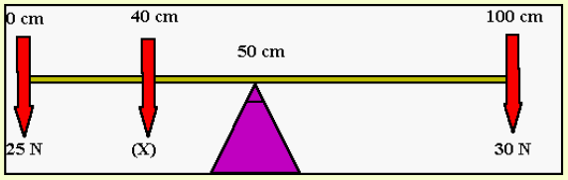

The torque questions like what is pictured above rely on the idea that $∑τ=0$. This means the torques on the left of the pivot are equal to the torques on the right.  
These questions can also be tricky in that the centre is defined as $50cm$, which means the force at $0cm$ is actually at a radius of $50cm$ etc.

### Banked Curves

In a typical banked curve question the centripetal force is considered to be the inward component of the normal force and the vertical component of the normal force is the opposite of gravity.

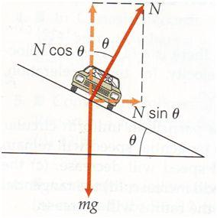

### Tension as Centripetal Force

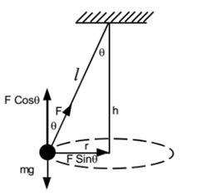

In this example of circular motion, the vertical component of tension is the force opposing gravity and the horizontal is the centripetal force.

The interesting implication of this is that when you swing an object on a string in real life, it can never be perfectly flat, there will always be a slight angle between the string and the vertical.

### Static Friction around a Corner

Going around a flat corner, the static friction acts as the centripetal force. In physics we don’t consider other effects which are why you typically accelerate around a bend when driving.

Summary: $μ_{s}N≥\frac{mv^{2}}{r}$

### Change in Potential Energy in a Gravitational Field

By definition, any change is the final state minus the initial state:

$$ΔU=U_{f}-U_{i}$$

Given $U_{G}=-\frac{Gm_{1}m_{2}}{r}$, $ΔU=-Gm_{1}m_{2}\left(\frac{1}{r_{f}}-\frac{1}{r_{i}}\right)$

This $ΔU$ will also return a positive or negative value, if it is positive, work has been done against the field. If it is negative, then the field has done work.

The final useful definition is that $-ΔU=ΔE_{K}$

#### Harder Potential Energy Concepts

Applying this formula is harder when the concept of ‘*altitude*’ is introduced. When the word *altitude* is in the question it is implying that $r=r_{E}+a$, where $a$ is the altitude.

Some other problems also introduced where energy is lost to something like air resistance as heat. In this instance the heat energy lost is subtracted from the kinetic energy gained due to the loss of potential energy i.e. ${ΔE}_{k}=-ΔU-Q$ (The increase in kinetic energy is the decrease in potential energy minus the heat energy)

### Orbital Motion in a Gravitational Field

In orbital motion, the gravitational force is the centripetal force ($F_{G}=F_{c}$)

i.e. $G\frac{m_{1}m_{2}}{r^{2}}=\frac{mv^{2}}{r}$

#### Geostationary Satellites

The definition of a geostationary satellite is that it orbits with a period of 24hrs (86400s). Every other fact about geostationary satellites is consistent with circular motion in a gravitational field.

### Kepler’s Laws

#### 1st Law

Planets orbit in ellipses with the Sun at one of the foci.

#### 2nd Law

The imaginary line connecting the planet and the sun sweeps out the same area per unit time no matter how fast it is going or where it is.

#### 3rd Law

$$\frac{GM}{4π^{2}}=\frac{r^{3}}{T^{2}}$$

Where $r$ is the orbital radius, $T$ is the time for one orbit and $M$ is the mass of the object causing the orbit.

### Formula Derivations

#### Kepler’s Third Law

*Q.E.D.*

$$F_{G}=F_{c}$$

$$G\frac{m_{1}m_{2}}{r^{2}}=\frac{m_{2}v^{2}}{r}$$

$$\frac{Gm_{1}}{r}=v^{2}$$

$$v=\frac{2πr}{T}$$

$$\frac{Gm_{1}}{r}=\frac{4π^{2}r^{2}}{T^{2}}$$

$$\frac{Gm_{1}}{r^{3}}=\frac{4π^{2}}{T^{2}}$$

$$\frac{Gm_{1}}{4π^{2}}=\frac{r^{3}}{T^{2}}$$

#### Escape Velocity

*Q.E.D.*

$$E_{K}={-U}_{G}$$

$$\frac{1}{2}mv^{2}=G\frac{Mm}{r}$$

$$v^{2}=\frac{2GM}{r}$$

$$v_{esc}=\sqrt{\frac{2GM}{r}}$$

#### Velocity of a Satellite

*Q.E.D.*

$$F_{c}=F_{G}$$

$$\frac{mv^{2}}{r}=G\frac{Mm}{r^{2}} ⇒ v^{2}=\frac{GM}{r} ⇒ v=\sqrt{\frac{GM}{r}}$$

#### Total Energy of an orbiting Object

$$E_{net}=E_{k}+U_{G}$$

$$=\frac{1}{2}mv^{2}-\frac{GMm}{r}$$

$$\frac{GMm}{r^{2}}=\frac{mv^{2}}{r}$$

$$\frac{GM}{r}=v^{2}$$

$$E_{net}=\frac{1}{2}m\left(\frac{GM}{r}\right)-\frac{GMm}{r}$$

$$=\frac{1}{2}\frac{GMm}{r}-\frac{GMm}{r}$$

$$=-\frac{GMm}{2r}$$

# Electromagnetism

## Base Units

Charge ($q$) – Coulombs ($C$) or Amp Seconds ($As$)

Electric Field ($\overset{⃑}{E}$) – Newtons per Coulomb ($NC^{-1}$) **or** Volts per Meter ($Vm^{-1}$)

Magnetic Field ($\overset{⃑}{B}$) – Tesla ($T$)

Magnetic Flux ($ϕ_{B}$) – Weber ($Wb$) **or** Tesla Square Metres ($Tm^{2}$)

Electric Potential ($U_{E}$) – Joules ($J$) **or** Volt Coulombs ($VC$)

Voltage ($V$) – Volts ($V$) **or** Joules per Coulomb ($JC^{-1}$)

Current ($\overset{⃑}{I}$) – Amperes ($A$) **or** Coulombs per Second($Cs^{-1}$)

## Constants

Permittivity of Free Space $ε_{0}=8.854 ×{10}^{-12}$ ($A^{2}s^{4}kg^{-1}m^{-3}$)

Permeability of Free Space $μ_{0}=4π ×{10}^{-7}$ ($NA^{-2}$)

Mass of an Electron $m_{e}=9.109×{10}^{-31}$ ($kg$)

Mass of a Proton $m_{p}=1.673×{10}^{-27}$ ($kg$)

Mass of a Neutron $m_{n}=1.675×{10}^{-27}$ ($kg$)

Charge of an Electron $q_{e}=-1.602×{10}^{-19}$ ($C$)

Charge of a Proton $q_{e}=+1.602×{10}^{-19}$ ($C$)

## Equations

### Electrostatics

*The Force on a charged particle due to an electric field. The direction is given by the direction of the field however if the charge is negative, it experiences a force in the opposite direction to the direction of the field.*

$$\overset{⃑}{F}=q\overset{⃑}{E}$$

$$E=\frac{V}{d}$$

*The formula for Electric field as a function of the scalar voltage field.*

$$W=qV=q\overset{⃑}{E}∙\overset{⃑}{d}=qE_{∥}d$$

*Work done on a charged particle in an electric field is the change in electric potential energy.*

$$E_{1}=\frac{1}{4πε_{0}}∙\frac{q_{1}}{r^{2}}$$

*The electric field at a radius due to a charged particle $q_{1}$.*

$$F=\frac{1}{4πε_{0}}∙\frac{q_{1}q_{2}}{r^{2}}$$

*The magnitude of force on a pair of charge particles at a radius (Coulomb’s Law).*

### Circuits

*Ohm’s Law*

$$V=IR$$

$$I=\frac{q}{t}$$

*Current is the number of charges passing a point per second.*

*The power output in a circuit is the number of charges passing per second (current) multiplied by the energy lost by each particle across a component in the circuit (voltage).*

$$P=IV=I^{2}R=\frac{V^{2}}{R}$$

### Magnetism

$$B=\frac{μ_{0}I}{2πr}$$

*The magnitude of the electric field at a perpendicular radius from a current carrying conductor.*

$$B=μ_{0}I\frac{N}{L}$$

*The magnitude of the magnetic field inside a solenoid with N turns and length L.*

$$\overset{⃑}{F}=q\overset{⃑}{v}×\overset{⃑}{B}=q{\overset{⃑}{v}}_{⊥}\overset{⃑}{B}=qvB\sin{θ}$$

*The force on a charged particle moving through a magnetic field. Due to the cross product, the force is always perpendicular to the velocity and, as such, will always induce some form of circular motion.*

$$\overset{⃑}{F}=l\overset{⃑}{I}×\overset{⃑}{B}=l{\overset{⃑}{I}}_{⊥}\overset{⃑}{B}=lIB\sin{θ}$$

*The Motor Effect: The force on a current carrying conductor of length $l$ in a magnetic field.*

$$\frac{F}{l}=\frac{μ_{0}}{2π}∙\frac{I_{1}I_{2}}{r}$$

*The force per length on a pair of current carrying conductors. Note that for net force, $l$ is the length of the two wires which are parallel (the common length).*

$$ϕ_{B}=\overset{⃑}{B}∙\overset{⃑}{A}={\overset{⃑}{B}}_{∥}\overset{⃑}{A}=BA\cos{θ}$$

*Magnetic Flux through an area. Note that $\overset{⃑}{A}$ denotes the area vector which is at $90°$ to the surface.*

### Electromagnetism

$$\overset{⃑}{F}=q(\overset{⃑}{E}+\overset{⃑}{v}×\overset{⃑}{B})$$

*The net force on a charged particle due to both a magnetic and electric field.*

$$ε=-N\frac{Δϕ_{B}}{Δt}$$

*E.M.F. induced in a coil with $N$ turns (Faraday-Lenz Law).*

$$\overset{⃑}{τ}=NI\overset{⃑}{A}×\overset{⃑}{B}=NI{\overset{⃑}{A}}_{⊥}\overset{⃑}{B}=NIAB\sin{θ}$$

*The torque on a rectangular current carrying coil with N turns in a magnetic field.*

### Transformers

$$\frac{V_{P}}{N_{P}}=\frac{V_{S}}{N_{S}}$$

*Voltage per turn ratio for a transformer is constant.*

$$V_{P}I_{P}=V_{S}I_{S}$$

*The power output for the primary and secondary coils in an ideal transformer is the same.*

## Course Notes

### Charges Moving in an Electric Field

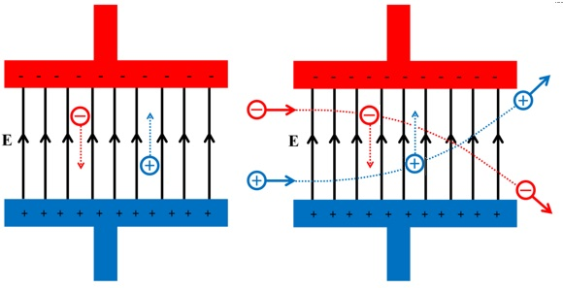In these types of problems, the same logic from projectile motion is required but instead of gravity acting as the acceleration, it is the electric field. As such, the problem should be broken up such that the y-direction is parallel to the field and the x-direction is perpendicular to the field.

### Voltage

Voltage takes many forms in electromagnetism and can often be difficult to conceptualise. Voltage is often considered the ‘pushing force’ in electrical circuits but, really, it is a way of describing the potential for charges in a field to do work. This work done is why the voltage decreases across components of a circuit, the work was done therefore the potential to do work decreases.

Put simply, Voltage is the measure of the potential of the Electric field and can also be considered the potential energy per charge due to a field. As a result:

$$E=\frac{V}{d}$$

### The Magnetic Field

The Magnetic Field is an interesting field to consider as it only exists in certain reference frames (it is fictitious). By performing a Lorentz transform on charged particle moving next to a current carrying conductor, you will find that there is a force on it due to an increased density of charges, caused by length contraction within the wire. The same is not true for a permanent magnet as the magnetism of atoms is due to the magnetic moments of the electrons in the shells.

### Charges Moving in a Magnetic Field

For charges to experience a force in a magnetic field, they must be moving. This is due to the effects of special relativity and you can find more details on this on the Veritasium YouTube channel: (<https://www.youtube.com/watch?v=1TKSfAkWWN0>). This also means that the magnetic force is fictitious, as in, it only exists in certain frames of reference.

The force, because it is a result of the cross product of velocity and the field, will always result in a force which is perpendicular to both the field and velocity, the direction is given by the right-hand rule. As a result of it being perpendicular to the velocity, it can never produce energy (the force can never do work) and will always result in circular motion. (i.e. ${\overset{⃑}{F}}_{B}=\frac{mv^{2}}{r}$)

### Flux

There are two forms of flux in electromagnetism, electric and magnetic. However, the HSC course is only concerned with **magnetic flux** ($ϕ_{B}$). Flux is a measure of the amount of field which passes through the defined area and, as such, can be defined as the field which is perpendicular to the area, or the field which is parallel to the area vector.

The way of making sense of this is imagining you are looking at a piece of paper on a table from above. Now you begin to look at the piece of paper from a lower angle, slowly beginning to look at it so you can only see the very thin edge. The apparent decrease in size of the paper is the same as *effective area* and is analogous to amount of area a magnetic field can pass through.

#### The Area Vector ($\overset{⃑}{A}$)

The area vector for any 2D surface has the magnitude of the area, and points perpendicular to the surface. Which side the vector points in is arbitrary, but it is important the definition remains consistent in the scenario i.e. if it is defined as pointing up at the start of a rotation, after half a revolution, it should be pointed down.

### Induction

Induction is the process through which a Voltage or E.M.F. is induced across a circuit. This can happen due to two different effects:

1. A conductor moving in a magnetic field
2. A changing magnetic flux through a conductive loop.

In the first form of induction, the E.M.F. is produced by the force on each of the charged particles as the conductor moves. Because a conductor is made of protons and electrons, as it moves through the magnetic field, the charges experience a force. The E.M.F. generated is the work done by the force per charge and, for a rod, is given by the equation (where $θ$ is the angle between $v$ and $B$):

$$ε=vlB\sin{θ}$$

In the second form of induction, it is slightly more abstract as to what causes the voltage as it is a **change in magnetic flux**. Due to Maxwell’s equations defining flux through a 3D object as zero, the flux must instead be through a 2D surface. As a result, the area which the flux is generated by is the area traced by a conductive coil and the E.M.F. can be defined as follows for a coil with N turns:

$$ε=-N\frac{Δϕ_{B}}{Δt}$$

The change in flux can be generated in a few ways:

* Turning on/off a magnetic field source
* Moving a magnet or solenoid through the coil
* Moving the coil away/towards a magnet

#### Why does this effect exist?

It’s not entirely clear why this effect occurs, even to experienced physicists. However, there is a more fundamental law which may help to explain where this comes from.

#### A Note on the Difference Between Relative Motion and Changing Flux

Many people like to speculate that movement of a magnet across a coil is equivalent to movement of the coil across a magnet. Although these both result in the same phenomenon, they are not mathematically equivalent (i.e. situation 1 and 2 below are equivalent).

Many people like to say that when the coil is moved that the electrons in the coil are moving in a magnetic field and the magnet being moved across the coil can be treated as such. This is not completely true. If you shift into the coil’s frame of reference, then yes this is true, and you can achieve the same result by doing so however in the lab frame only the magnet is moving. However, in the lab frame the magnetic field’s value at each point in space is changing but the field itself cannot ‘move’ and as such, treating it this way from the lab’s frame of reference is incorrect.

If you are unconvinced, try to prove that these two equations are, in the general case, equivalent as this is what is required to show that the two frames of references are mathematically equivalent.  
(1 is the equation which describes situation 1 and 2 for situation 2)

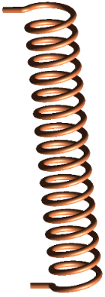

**Situation 1**

**Situation 2**

**1**

$$ε=-\frac{dϕ_{B}}{dt}$$

**2**

$$ε=\oint{(\overset{⃑}{v}×\overset{⃑}{B})∙d\overset{⃑}{l}}$$

#### Electromagnetic Beaks

Electromagnetic breaks use changing flux to create eddy currents which are attracted back towards the magnet which caused them.

The eddy currents created make their own magnetic fields, allowing them to be treated as a magnet. Due to Lenz’s law the little areas of the wheel ‘want’ to retain the same magnetic flux that they had, so the parts of the wheel getting closer to the magnet will create a field which repels them from the magnet and the parts getting further away will create a field which pulls them back.

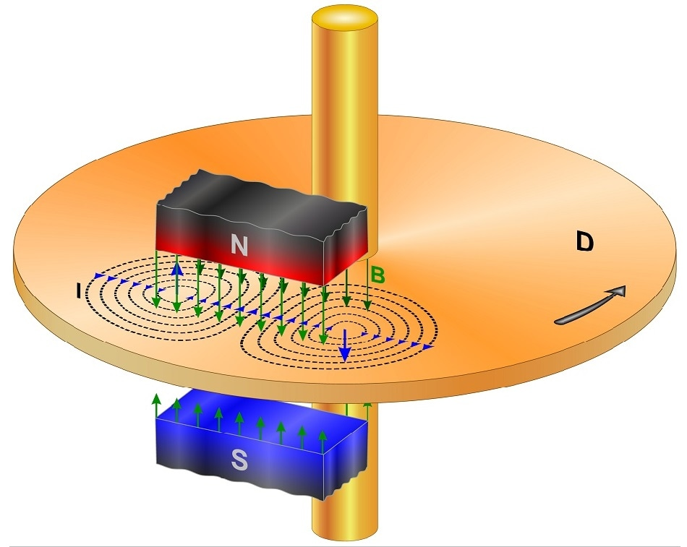

Attractive force due to decreasing magnetic flux.

Repulsive force due to increasing magnetic flux.

$$F_{B}$$

$$F_{B}$$

$$F_{B}$$

$$F_{B}$$

### The Motor Effect

This is the application of moving charges in a magnetic field. The motor effect is merely the notion that charges moving through a current carrying conductor will experience a force. As the charges experience a force, they will move, attracting the conductor with them. This is the mechanism through which the entire wire, not just the charges experience a force.

#### Deriving the Motor Effect

$$q\overset{⃑}{v}×\overset{⃑}{B}=\frac{d}{dt}q\overset{⃑}{s}×\overset{⃑}{B}=\left(\frac{dq}{dt}\overset{⃑}{s}+q\frac{d\overset{⃑}{s}}{dt}\right)×\overset{⃑}{B}=\left(\frac{dq}{dt}\overset{⃑}{s}+\overset{⃑}{0}\right)×\overset{⃑}{B}=s\frac{\overset{⃑}{dq}}{dt}×\overset{⃑}{B}=l\overset{⃑}{I}×\overset{⃑}{B}$$

### Motors

#### DC Motors

Motors are devices which take advantage of the Motor Effect to produce rotation.

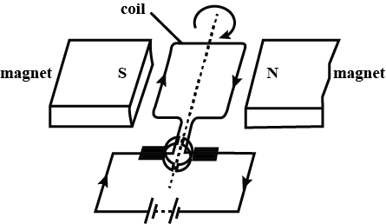

There are two common questions which arise when considering the design of a motor:

1. How does one keep the torque uniform?
2. How does one keep the torque in the same direction?

The first problem of keeping the torque at a uniform strength across the rotation has two solutions. The first way to improve this is by using curved magnets. The curved magnets produce a magnetic field which, at the outer edge, is pointed towards or away from the centre. This type of field is known as a **radial** magnetic field.

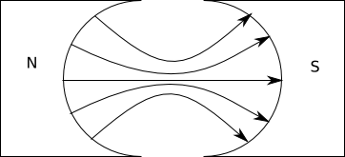

Because the field points in the same direction as the radius at the location of the arms, the angle between the force and the radius is a constant $90°$ at almost all times during the rotation. The end result is the torque produced is at a maximum value for all of the rotation (except when vertical).

Although this keeps the torque at a maximum for most of the rotation, the torque is not uniform due to the drop when the armature is vertical. To ensure the torque is completely uniform, there need to be more coils. If there are more coils, this drop of one armature as it reaches the vertical is counteracted by another coil at an offset. The more coils added to a motor, the more uniform the torque.

The second commonly considered problem with a motor is what happens when an arm of the armature (loop) changes from one side of the motor to the other (i.e. it becomes closer to the side with the North pole of the magnet).  
This would normally result in a change to the direction of the torque on the armature due to the direction of each arm changing from slightly upwards to slightly downwards or vice versa.   
This change in direction can be counteracted by a change in the current direction.

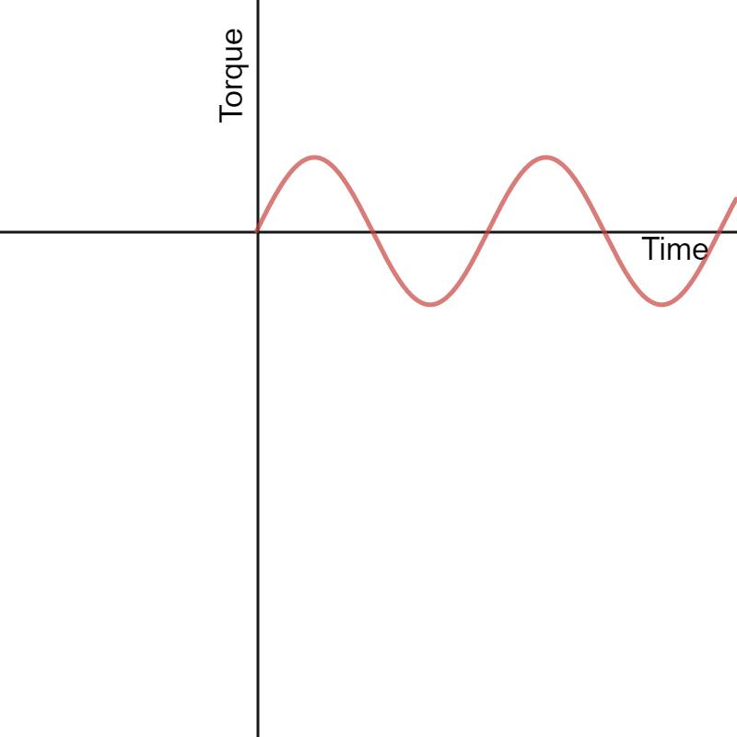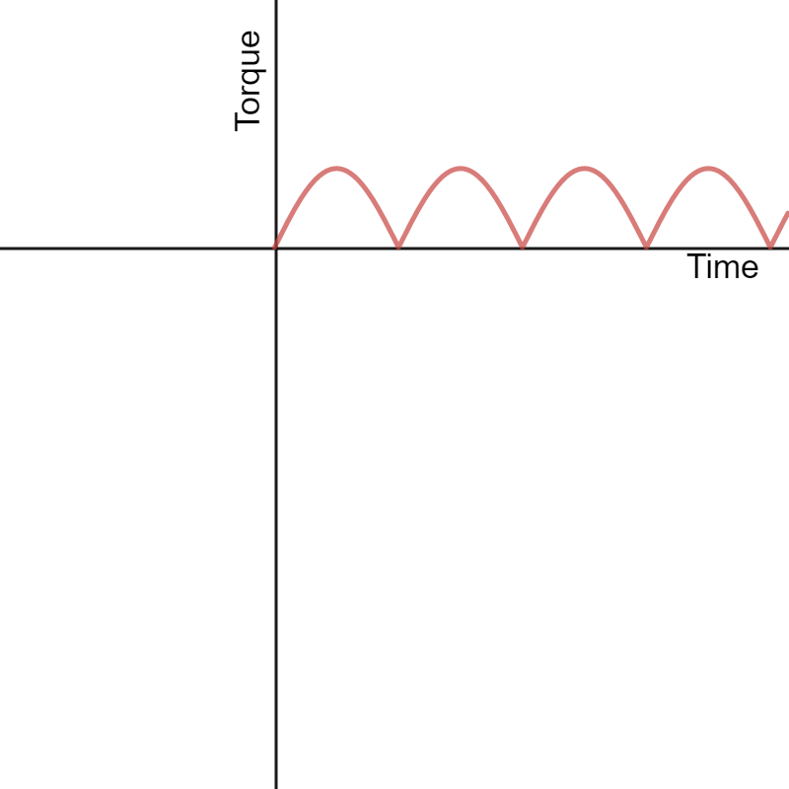

Torque where there is no change in current direction.

Torque where there is a change in current direction.

In a DC Motor, this change in current direction is achieved through a split-ring commutator, present in the image above. A split ring consists of semi-circular plates attached to each ending of the armature. The plates rotate with the motor and make contact with brushes, which are in turn connected to a voltage supply. As the motor rotates to this point, each plate breaks contact with a brush and connects to the other brush, changing the direction of the voltage across the armature. This then reverses the direction of the current and therefore the force. This acts as a sort of double reversal, keeping the torque in the same direction.

#### AC Induction Motors

An AC Induction motor works by utilising 3-phase AC power to create a rotating magnetic field inside the motor. This is analogous to the stator (external magnets) being rotated around the coil in a regular motor.

This induces a current in the coil which causes it to be ‘dragged’ by the field. The coil (or squirrel cage) inside the motor will be dragged with some torque due to the changing magnetic flux until it is rotating at the same speed as the field. The Squirrel Cage is a special type of coil which maximises magnetic flux and torque in this setup.

[](https://qph.fs.quoracdn.net/main-qimg-761c1578ba986b596964a9b9d7d6bff7)

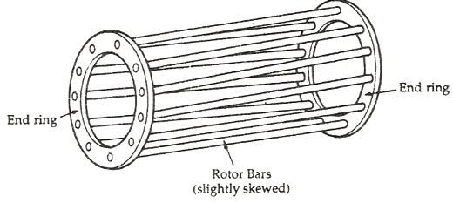

Click if not animated

### Generators

Generators work in reverse to motors, so instead of supplying power to turn a coil, a coil is turned, generating power.

The act of spinning the coil through a magnetic field creates a force on the electrons in the moving wires, generating a voltage. The voltage generated by this is the same as the back E.M.F. created when the motor is spinning and is in the same direction as when the motor spins in a given direction.

Due to a current being generated in the coil as it is rotated, there is also a force acting as a torque in the opposite direction, resisting the rotation of the generator. This force is described by the equation: $$\overset{⃑}{F}=l\overset{⃑}{I}×\overset{⃑}{B}$$ 
This can be rationalised by considering that if there was no resisting torque, or the torque acted in the other direction, there would be an infinite amount of energy generated (i.e. once it was started it would never stop or it would infinitely generate more energy).

#### DC Generators

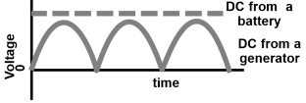A DC Generator makes use of the same equipment as a DC motor. As with motors, the current direction flips every half turn and, as a result, the current generated would be AC.  
To stop this from happening, a split-ring commutator is used, reversing the current again every half turn, keeping the current direction the same. In an ideal DC generator, the graph follows an $\left|\sin{ωt}\right|$ graph but in reality, there is a sudden drop before it reaches its minima each time (as the commutator loses contact slightly before the transition).

#### AC Generators

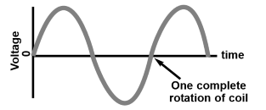AC generators are actually rather simple as they use the same setup as a DC motor except without a commutator (use a slip ring instead). As already discussed, the direction of force in a DC motor swaps every half turn. In a generator, because the rotation is in a constant direction and being created by an external entity, this reversal still occurs but instead it is the direction of the voltage being generated which swaps. As a result, the direction of the current swaps every half turn which, by definition, is the generation of an Alternating Current.  
This is carried away for use through a slip-ring commutator, which doesn’t swap the direction of the current. A slip-ring commutator can be thought of as though you attached an alligator clip to each end of the coil and magically made them unable to tangle

### Transformers

Transformers perform a simple but important task: changing the voltage in an AC circuit. Transformers are made from two coils and a circular or rectangular iron core which both coils are wound around.   
One coil, called the primary coil, is connected to power and has an alternating current put through it (often 50Hz for Australia) which then generates an alternating magnetic field in the solenoid. This magnetic field then induces a magnetic field in the iron core, which then channels the magnetic field around the iron loop and through the other coil, called the secondary coil.  
The changing magnetic flux through the secondary coil caused by this process creates an E.M.F. which also alternates at the same frequency. By changing the number of turns of the secondary coil, the amount of E.M.F. produced changes. By increasing the number of coils, the voltage increases from the primary to secondary coils (step up) and be decreasing the number of turns the voltage drops (step down).

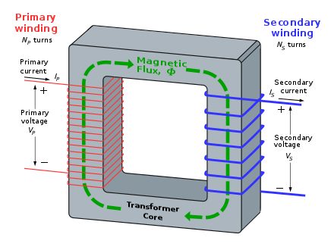Transformer equations rely on the assumption that energy is conserved in the voltage transformation from coil to coil. As a result, when a voltage step-up occurs, there must be a current step-down and vice versa.

#### Laminations

Laminations are used in transformers to prevent eddy currents from being induced in the iron core. Eddy currents can be a big problem for the efficiency of transformers due to the fact that they use alternating current at high frequencies, which creates a changing magnetic field. Due to the frequency at which this changing magnetic field oscillates, the E.M.F. it would create is massive, which would normally create large eddy currents which would ruin the efficiency of the transformer. To counteract this, plastic laminations are used, parallel to the direction of the magnetic field within the metal core. The laminations reduce the area of the core to small sections, which prevents large currents from forming by reducing the maximum E.M.F. in each section to a smaller value. This increases the effectiveness of the core at channelling the $\overset{⃑}{B}$ field.

Potential $ε$

Laminations which prevent large eddy currents.

Resultant currents

# The Nature of Light

## Base Units

Length ($l$) – Metres ($m$)

Time ($t$) – Seconds ($s$)

Speed ($v$) – Metres per second ( $ms^{-1}$**or $m/s$**)

Electric Field ($\overset{⃑}{E}$) – Newtons per Coulomb ($NC^{-1}$) **or** Volts per Meter ($Vm^{-1}$)

Magnetic Field ($\overset{⃑}{B}$) – Tesla ($T$)

Wavelength ($λ$) – Metres ($m$)

Frequency ($f$) – Hertz ( $Hz$**or $s^{-1}$** )

Energy ($E$) – Joules ($J$**or $kg m^{2} s^{-2}$**  )

Intensity ($I$) – Power per area ( $J m^{-2} s^{-1}$**or $kg s^{-3}$**  )

## Constants

The Speed of Light $c=3.00×{10}^{8} \left(m s^{-1}\right)$  
Permittivity of Free Space $ε_{0}=8.854 ×{10}^{-12}$ ($A^{2}s^{4}kg^{-1}m^{-3}$)

Permeability of Free Space $μ_{0}=4π ×{10}^{-7}$ ($NA^{-2}$)

Planck Constant $h=6.626×{10}^{-34} \left(kg m^{2} s^{-1}\right)$

Wein’s Displacement Constant $b=2.898×{10}^{-3} \left(m^{2}s^{-2}K^{-1}\right)$

## Equations

*Describes the angular location of the $m^{th}$ bright spot on a wall due to double slit interference (or dark spots for single slit interference).*

$$d\sin{θ}=mλ$$

*Describes the angular location of the $m^{th}$ bright spot due to single slit interference ($+$); and the $m^{th}$ dark spot on a wall due to double slit interference ($-$).*

$$d\sin{θ}=\left(m±\frac{1}{2}\right)λ$$

*Wein’s Law for Blackbody radiation.*

$$λ_{max}=\frac{b}{T}$$

*Malus’ Law - The intensity of light that has passed through a polarising filter with $θ$ the difference between the angle of the polarizing filter’s axis and the polarization direction of the light.*

$$I=I_{0}\cos^{2}{θ}$$

*The maximum amount of kinetic energy an electron can receive from a photon of some frequency $f$ where $ϕ$ is the work function of the material and $f_{0}$ the critical frequency of the material.*

$$K_{max}=hf-ϕ$$

$$ϕ=hf_{0}$$

## Extension Equations

*The intensity of a light ray as a function of its maximum Electric and Magnetic field magnitudes.*

$$I=\frac{{E_{0}}^{2}}{2cμ_{0}}=\frac{c{B_{0}}^{2}}{2μ_{0}}$$

*The power output of a wave is the 2D surface integral of the intensity over the area.*

$$P=\oint{\overset{⃑}{I}∙d\overset{⃑}{A}}$$

## Course Notes

### Attempts to Measure the Speed of Light

#### Galileo

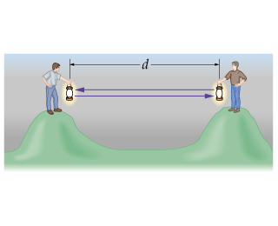Galileo and his assistant stood on top of hills a reasonable distance (a few kilometres) apart. Galileo uncovered his lamp. His assistant uncovered his lamp once he saw Galileo’s light and Galileo noted the time it took for him to see the light again.  
He compared this to the time measured at a very small distance (i.e. human reaction time in his lab) and noticed that there was almost no difference. From this he concluded that the speed of light was a minimum speed of the distance between the hills over human reaction time measured in the lab and could be anywhere from this speed to infinite.

#### Romer

Romer was making measurements of the time at which the eclipse of one of Jupiter’s moons Io occurred. Romer noticed that the time at which it appeared to occur followed a sine curve, with a period of one year.   
He reasoned that this curve was occurring due to the orbit of the earth around the sun and that this delay must therefore be due to the speed of light travelling longer distances as earth moved to the other side of the sun.

Using the known radius of earth’s orbit, he estimated the speed of light to be $220, 000, 000 m s^{-1}$

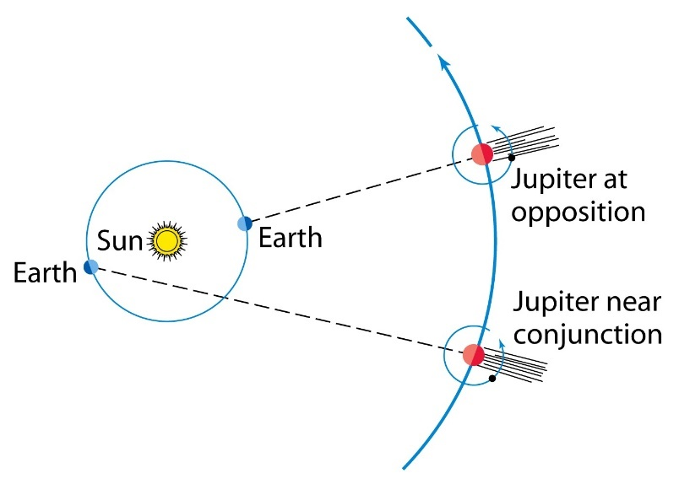

#### Fizeau

Fizeau used a toothed wheel with known angular speed and angular distance between the teeth. Fizeau passed light pulses through the holes in the teeth and then sped the gear up until the light pulses did not make it through. This meant that the next tooth was getting in the way of the pulse. Because he knew the angular separation of the teeth and the angular speed of the wheel, he calculated the minimum and maximum time the light could be taking after passing through the gap to make it back and hit the tooth. $\left(t=\frac{1}{nf}, n=teeth\right)$

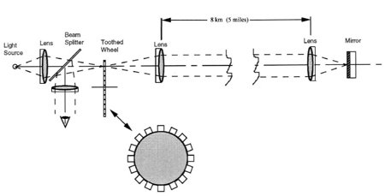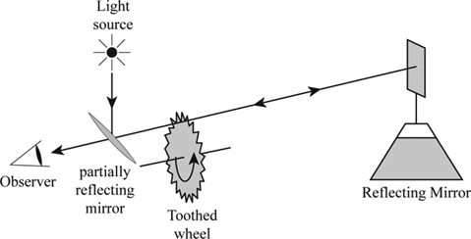Using the known (large) distance between the mirror and the wheel, he calculated the speed of light using $c=\frac{d}{t}$ to be $3.15×{10}^{8} m s^{-1}$

#### Michelson

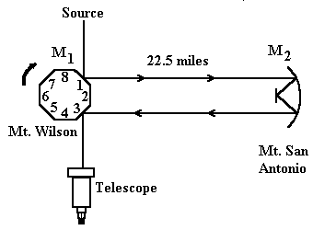Michelson’s rotating mirror experiment is very similar to Fizeau’s experiment in that it relied on the precise lining up of rotating objects with a ray of light. Michelson’s experiment was, however, more precise than Fizeau’s as it could use a continuous beam of light rather than pulses.

At first, the mirror is stationary such that the beam perfectly reflects towards the observer. If the mirror rotates even a little bit, the beam will not reach the observer. The key part of this is that the mirror must be in this orientation for the light to reach the observer.

Once the mirror starts rotating, the beam doesn’t reach the observer because by the time the light has travelled the distance, the mirror has rotated to a different orientation.

The next time the beam will be seen is when the mirror is rotating such that:

* The beam reflects off side 1
* As the beam travels the distance, the mirror continues to rotate
* When the beam reaches the mirror, it has done exactly $\frac{1}{8}$ of a rotation and is back in the ideal state, with the light reflecting to the observer from side 2

This means the time taken for the beam to travel the large distance is $t=\frac{1}{8f}$ and the speed is $c=\frac{2d}{t}$

Michelson’s measured the speed of light to be $299, 979, 000 m s^{-1}$ (withing 0.1%)

#### The Hertz Experiment

Hertz set out to experimentally prove two of Maxwell’s predictions. As such he did two main things:

1. He assumed that light was an electromagnetic wave
2. He used the know relationships for waves to find the speed

If the assumption could be shown to be true and then the speed measured closely matched the prediction, then he could verify Maxwell’s prediction.

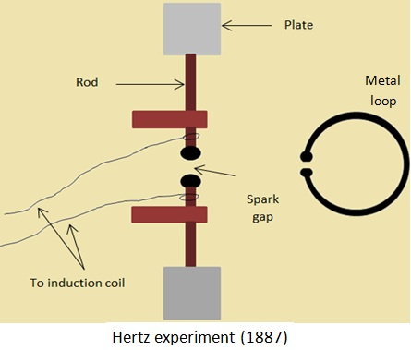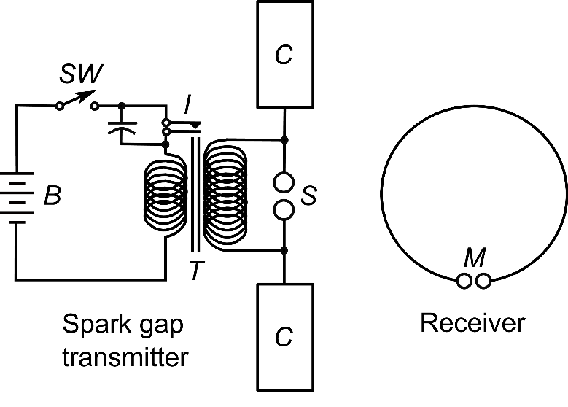

The experiment above cause a spark of electrons undergoing a high acceleration to pass between the spark gap. This created radio waves which were emitted in all directions (which were already known to be a type of light). The setup was created in a way that Hertz already knew the frequency of the wave.

By placing a metal reflector some distance from the emitter, he created a standing wave pattern between the emitter and the plate, where the gap between nodes is half the wavelength.

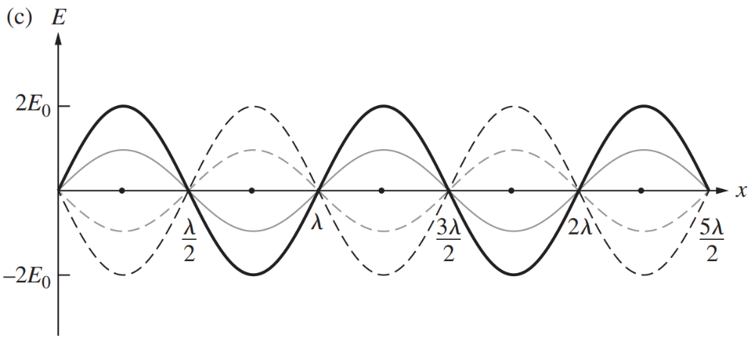

Now comes the assumption. If light is an electromagnetic wave, then the oscillating magnetic field of this standing wave will induce a current (and therefore a spark) in the loop detector at all points except the nodes. This was indeed the case.

By measuring the distance between points where there was no induced spark, Hertz measured the wavelength of the wave (which he already knew the frequency for).

Due to experimental error in calculating the frequency output of the device and error induced by an inversion of the wave upon reflection, Hertz could only conclude that the speed of light was finite and approximately $3×{10}^{8} m s^{-1}$ (but with a large degree of uncertainty). This was enough to confirm Maxwell’s hypothesis.

More recent attempts at his experiment with better data (but the same experimental setup) give a value of $c≈3.4×{10}^{8} m s^{-1}$.

### Waves need a medium – so what about light?

Once physicists discovered that light was a wave, they began to hypothesise about what is the medium through which it travels?

#### Absolute Space and Time

When Newton was developing his theories, he reasoned that there must be some universal clock and universal zero point. This seemed particularly reasonable since all phenomena observed at the time appeared to happen at the same rate and across the same distances.

#### The Luminiferous Aether

Based on Newton’s idea of absolute space informed the construction of a theoretical medium called the aether. The aether was meant to be fixed to the universe’s zero point and was the medium through which light travelled with speed $c$.

This meant that as Earth travelled through the universe, it should have some velocity relative to the aether. This would create ‘aether winds’ which would slow down or speed up light depending on the relative velocity of the Earth to the respective light ray.

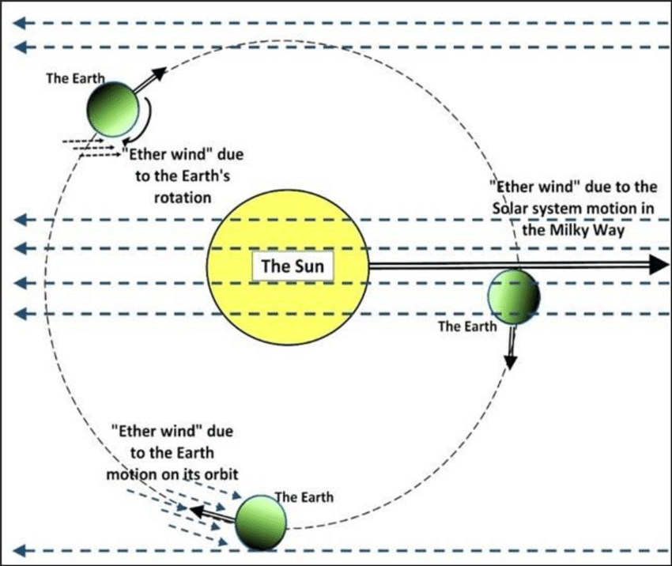

#### Michelson-Morley Experiment

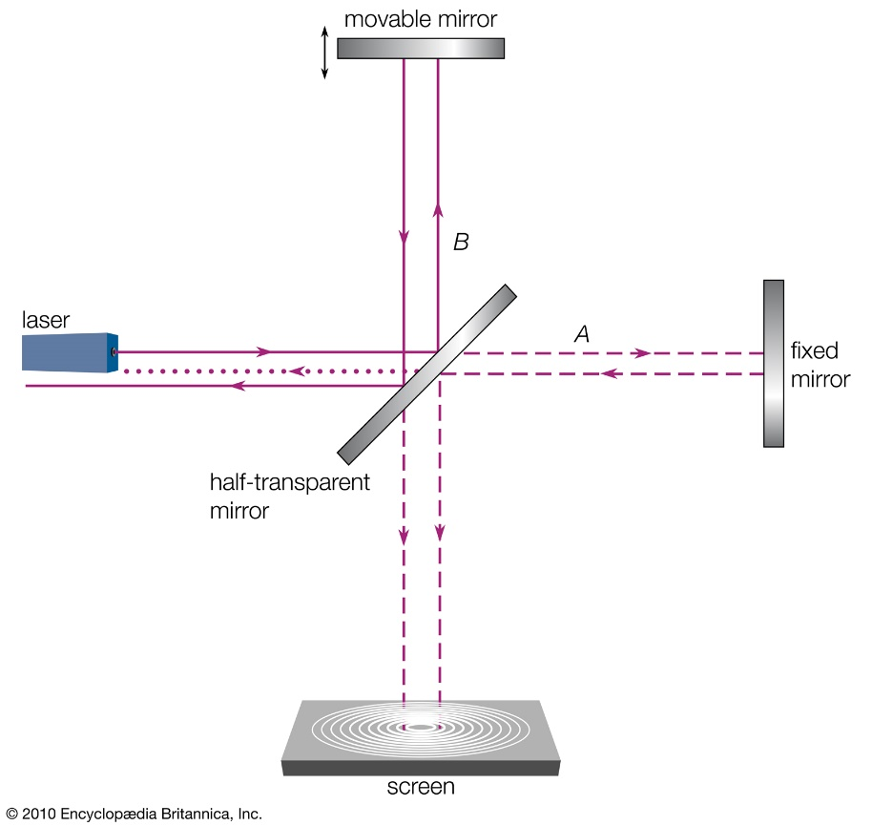The Michelson-Morley experiment set out to detect these aether winds. They hypothesised that at a certain point in time and certain spot on Earth there is a given aether wind direction. Using their setup (below), should they rotate the apparatus, the relative speeds of each light ray will differ (they should bend depending on the angle to the aether wind) and a variable diffraction pattern should be produced as the apparatus is rotated.

The apparatus was floating on a mercury bath (because basically everything floats on mercury) allowing for it to be rotated smoothly while also isolating it from any vibrations from footsteps and the like.

The experiment yielded a null result (meaning nothing could be concluded). Due to the great precision of the experiment, and verification through repetition by other labs, it meant that the theory of the aether had to be revisited.

Although it was a null result, the discrepancy between the actual result and the theorised result meant that the theory had to be adjusted.

#### The Actual Medium for Light

The most current model of light says that there are magnetic and electric fields which permeate through all of space and it is the fields themselves which are the medium for light.

Waves need a medium because they need something to wave however it is the fields which wave, so light doesn’t need a physical medium. The medium is the fields as they are what do the waving.

### Diffraction

#### Double Slit

Double slit interference is somewhat easy to understand if you think about how waves work.

The assumptions of a double slit setup are that $X≫d$ and therefore that $\sin{θ}=\tan{θ}$

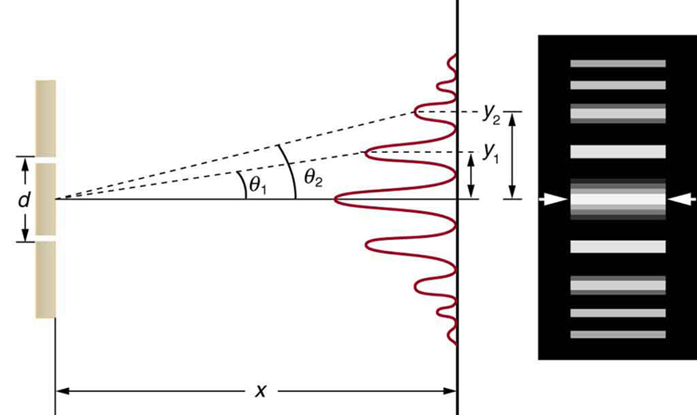

##### Formulae:

|  |  |  |
| --- | --- | --- |
| **Maxima** | | **Minima** |
| $$d\sin{θ_{m}}=mλ$$ | | $$d\sin{θ_{m}}=\left(m-\frac{1}{2}\right)λ$$ |
| **Distance from Centre of Maxima / Minima** | | **Gap Between Consecutive Maxima / Minima** |
| $$y=\frac{mλX}{d}$$ | $$y=\frac{\left(m-\frac{1}{2}\right)λX}{d}$$ | $$∆y=\frac{λX}{d}$$ |

##### Derivation of Formulae

$$y$$

$$θ$$

$$d$$

$$∆p$$

$$θ$$

$$X$$

###### Maxima

Condition for constructive interference is when the waves are in phase. Therefore, the distance covered by one wave must be an integer multiple of the wavelength (since they begin in phase).

Since $∆p=mλ, m∈Z$

$$\sin{θ}=\frac{∆p}{d}$$

$$d\sin{θ}=mλ$$

###### Minima

Similarly, deconstructive interference occurs where the waves are out of phase and therefore where the path difference is half a wavelength. The first minima will occur where the path difference is half a wavelength.

Since $∆p=mλ-\frac{1}{2}λ, m∈ Z$

$$\sin{θ}=\frac{∆p}{d}$$

$$d\sin{θ}=\left(m-\frac{1}{2}\right)λ$$

###### Height and Width of Peaks on Wall

|  |  |
| --- | --- |
| ***Height*** | ***Width*** |
| $$\sin{θ}=\frac{mλ}{d}=\tan{θ}=\frac{y}{X}$$ $$y=\frac{mλX}{d}$$ | $$∆y=\frac{\left(m+1\right)λX}{d}-\frac{mλX}{d}$$ $$∆y=\frac{λX}{d}$$ |

#### Single Slit

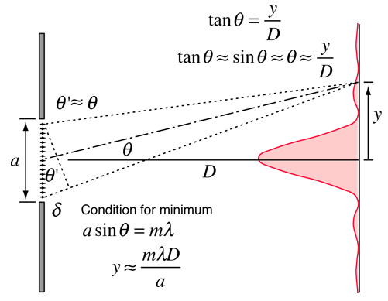Single slit interference is only qualitatively assessable in Yr. 12 HSC Physics however it isn’t terribly difficult. The main difference is that while in single slit interference the width of the centre peak is $2 ∆y$.

##### Formulae:

|  |  |  |
| --- | --- | --- |
| **Maxima\*** | | **Minima** |
| $$a\sin{θ_{m}}=\left(m+\frac{1}{2}\right)λ$$ | | $$a\sin{θ_{m}}=mλ$$ |
| **Distance from Centre of Maxima / Minima** | | **Gap Between Consecutive Maxima / Minima** |
| $$y=\frac{\left(m+\frac{1}{2}\right)λX}{a}$$ | $$y=\frac{mλX}{a}$$ | $$∆y=\frac{λX}{a}$$ |

\**There is technically no formula for maxima, but this gives the halfway point between two minima*

For Derivations see Khan Academy’s video:

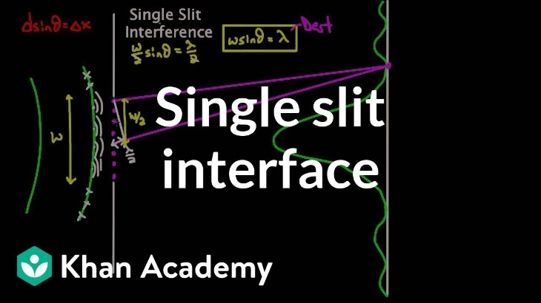

<https://www.khanacademy.org/science/physics/light-waves/interference-of-light-waves/v/single-slit-interference>

### The Quantum Nature of Light

#### Blackbody Radiation

A blackbody is an object which does not reflect light. All objects of mass emit heat as a function of their temperature (i.e. infrared temperature sensors) and a black body is just something which physicists can analyse (because physicists are lazy and can’t be bothered adjusting for light from the environment).  
The sun can be considered a black body because it gives off so much more light than it receives from the rest of the universe. It is possible that the sun is actually a perfect mirror but it’s about 10000000000000000000000000000000000000 times brighter than anything else, so no one cares.

##### The Ultraviolet Catastrophe

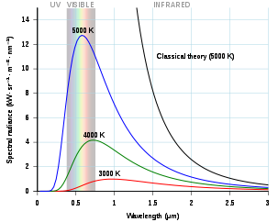‘The Ultraviolet Catastrophe’ is so named due to what is possibly the worst prediction to come from physics. Classical thermodynamics and electromagnetism predicted that a hot black body should emit an exponentially large amount of light in the ultraviolet, x-ray and gamma-ray side of the light spectrum. This violated both common sense and conservation of energy and was the first hint at a quantum nature of light.

Thermodynamics is also known as statistical mechanics and as such, the heat and light output of a blackbody is probabilistic (or statistical) in nature (its why the curve is a curve and not a bar graph). The peak light emission wavelength is derived by calculating the highest probability interaction between subatomic particles at a certain temperature and therefore all other wavelengths will have a lower probability of being produced.

##### The Mechanism for Blackbody radiation

The way blackbody radiation is produced is by the acceleration of charges when atoms and molecules collide and change velocity. When this occurs, the accelerating charges produced light waves and the principle of probability and temperature distributions still holds.

The current theory is defined by Wein’s law:

$$λ_{max}=\frac{b}{T}, b=2.898×{10}^{-3} \left(m^{2}s^{-2}K^{-1}\right)$$

#### The Photoelectric Effect

The Photoelectric effect was the first definitive evidence for the quantum nature of light as it completely contradicted classical electromagnetism. Although Blackbody radiation was unsolvable by classical physics, it did not completely contradict it, at least on a fundamental level.

Classical Electromagnetism says that the power output (energy per second) of a wave is proportional to its intensity:

$$P=\oint{\overset{⃑}{I}∙d\overset{⃑}{A}}=IA$$

It was therefore completely reasonable to assume that the greater the intensity of light, the greater the amount of energy the light would give electrons. Therefore, the energy electrons possess after being vibrated by a light wave should be proportional to the power of the light wave. This was not the case.

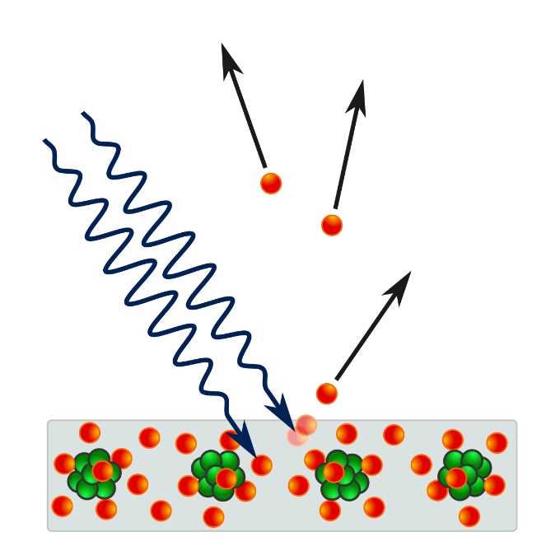Instead, the energy absorbed by an electron was a function of the frequency (intensity is not a function of frequency at all). This eventually led Einstein to conclude that this must be due to light coming in packets with energy $E=hf$ and intensity being due to an increase in the number of packets (eventually called photons) striking the surface.  
This was the beginnings of the quantised understanding of light.

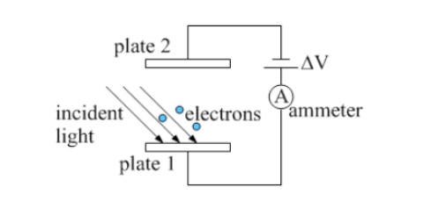

##### The Work Function $\left(ϕ\right)$

The work function is the lowest amount of potential energy which an electron possesses while part of the material. This is what gives rise to $K_{max}$ rather than just $K$ as it is the lowest amount of resistance the material provides to the electron being removed.

##### The Experimental Setup

The experiment is setup such that light is shone onto one of two parallel plates. A voltage can be applied to the plates so that there is an electric field between the two plates. This electric field can be setup to oppose the velocity of the emitted electrons.

Since the work done by the field is $W=qV$, if the work done by the field is greater than the maximum kinetic energy of the electrons, then the electrons will stop before they hit the other plate. So, if $V=\frac{K_{max}}{q}$ then no current will be detected. As such, if an electric field is established such that it just stops all electrons then $qV=hf-ϕ$

$∴ϕ=hf-qV$

### Polarisation

Polarised light is light with an electric field which only oscillates along one axis.

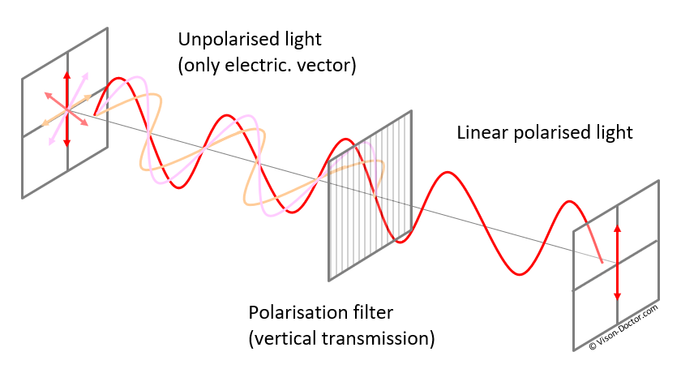Polarisation is typically understood using a wave model of light and splitting the field vector into components. In reality, it is a quantum phenomenon, with the polarisation of a photon being a function of its spin, something which is based on probabilities.

#### Wave Model – Derivation of Malus’ Law

It is somewhat easy to derive Malus’ Law when considering the assumptions of polarisation. If we consider light of a single polarisation direction. If we assume that a polariser blocks all electric field components of a light ray which are perpendicular to its axis, then we can consider the following:

A light ray is shone onto a polariser with its electric field $E_{0}$ oscillating on an axis at some angle $θ$ from the axis of the polariser.

$$θ$$

$$E_{0}$$

The (peak) component of the electric field which will be let through is the parallel component.

$$E=E_{0}\cos{θ}$$

$$E^{2}=E_{0}^{2}\cos^{2}{θ}$$

$$I=\frac{E^{2}}{2cμ_{0}}$$

$$\frac{E^{2}}{2cμ_{0}}=\frac{E_{0}^{2}}{2cμ_{0}}\cos^{2}{θ}$$

$$I=I_{0}\cos^{2}{θ}$$

#### Quantum Model

The quantum interpretation of light makes polarisation much harder to understand, but so is the nature of quantum. In reality, intensity is proportional to the number of photons which strike a surface. Photons possess a property called spin and this determines the direction of their electric field oscillation. When a photon is travelling through space, there is a degree of uncertainty in its spin. When a photon hits a polariser, it is interacting with it and therefore, its wave functions will collapse, and its spin will lose its uncertainty. The probability that the photon’s spin aligns with the polariser is:

$$P\left(align\right)=50\%$$

After this, the photons which pass through are all 100% aligned with the polariser. Should they come into contact with an analyser at an angle $θ$ to their polarisation axis, the probability that they will change their spin axis to the new spin axis is given by:

$$P\left(align\right)=\cos^{2}{θ}$$

(There are some very complicated calculations that can be done to figure this out with quantum physics but eventually you get this result).

This is particularly evident with three polarisers which are at different angles to each other (see [minutephysics](https://www.youtube.com/user/minutephysics)’ video on the topic):

<https://www.youtube.com/watch?v=zcqZHYo7ONs>

[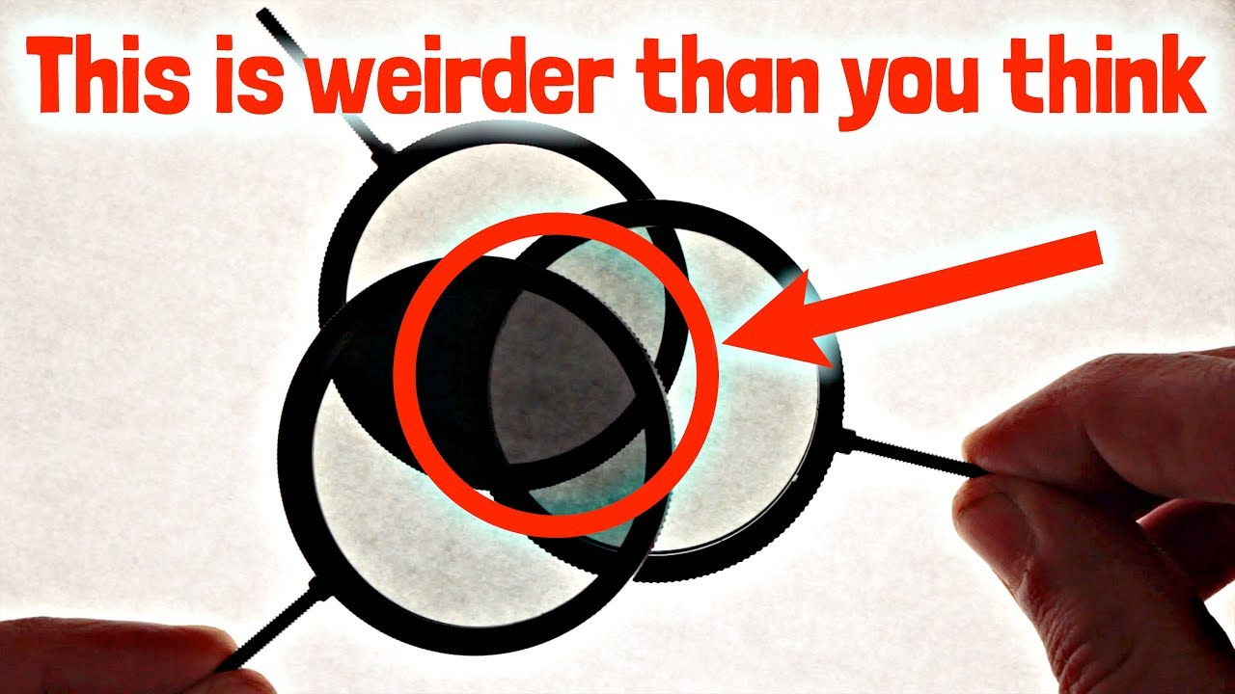](https://www.youtube.com/user/minutephysics)

### Light has Momentum?

Many teachers will mention that light has momentum and can move objects very slightly. This is due to the fact that $E=mc^{2}$ is only true for an object at rest.

The actual equation is:

$$E^{2}={\left(mc^{2}\right)}^{2}+{\left(pc\right)}^{2}$$

Where $p$ is the momentum.

Light has no mass, so the first term goes to zero.

$$E^{2}={\left(pc\right)}^{2}$$

$$E=pc$$

And since we know light has energy, it must have momentum. This is why light can cause small metal fans to move in vacuum chambers.

# Relativity

## Base Units

Mass ($m$) – Kilograms ($kg$)

Length ($l$) – Metres ($m$)

Time ($t$) – Seconds ($s$)

Speed ($v$) – Metres per second ( $ms^{-1}$**or $m/s$**)

Momentum ($\overset{⃑}{p}$) – Kilogram metres per second ( $kg ms^{-1}$**or $kg m/s$** )

## Constants

The Speed of Light $c=3.00×{10}^{8} \left(m s^{-1}\right)$

## Equations

### Galilean / Newtonian Relativity

$${\overset{⃑}{v}}_{A rel. to B}={\overset{⃑}{v}}_{A}-{\overset{⃑}{v}}_{B}$$

*The classical velocity transform for inertial reference frames. The equation relies on the velocities ${\overset{⃑}{v}}_{A}$ and ${\overset{⃑}{v}}_{B}$ both being taken from a third inertial reference frame.*

### Einsteinian / Special Relativity

*Known as the Lorentz Factor. It is used in Space-Time diagrams as part of the Lorentz Transform and appears frequently in Special Relativity. $β$ is the fraction of the speed of light the object is travelling at (i.e. if $v=0.8c, β=0.8$).*

$$γ=\frac{1}{\sqrt{1-\frac{v^{2}}{c^{2}}}}=\frac{1}{\sqrt{1-β^{2}}}$$

*The formula for time dilation. This transforms the time taken for some event in a stationary reference frame $\left(t_{0}\right)$ into the time taken in a reference frame in motion with respect to the event $\left(t\right)$.*

*The effect of this is that $t$ is always larger than $t_{0}$.*

$$t=γt_{0}$$

$$l=\frac{l_{0}}{γ}$$

*Describes the contraction of the space that a moving object inhabits. Space contracts along the axis of motion to a length of $l$, where the length of the stationary object is $l_{0}$.*

*It is therefore important to note that a moving object will observe all of space around it, including the distances between objects as shrinking.*

$$\overset{⃑}{p}=γ m_{0}\overset{⃑}{v}$$

*The apparent momentum of an object with some velocity $\overset{⃑}{v}$ with respect to another object.*

*The total energy of a particle or object, where m is the rest mass, $p$ the momentum, and $c$ the speed of light. In a situation where there is no relative motion, $p$ is 0 and the equation simplifies to $E=mc^{2}$.*

$$E^{2}={\left(mc^{2}\right)}^{2}+{\left(pc\right)}^{2}$$

$$E=γmc^{2}$$

## Course Notes

### Inertial Reference Frames

An inertial reference frame is the frame of reference of any object moving at a constant speed.  
It is impossible to determine from within an inertial reference frame whether you are moving.

### Non-Inertial Reference Frames

A non-inertial reference frame is any reference frame which is undergoing acceleration. This could be an accelerating rocket, or an object being spun in a circle. It is possible to tell whether you are in a non-inertial reference frame due to pseudoforces, for example the centrifugal force a rotating object appears to feel, or the backwards force felt within an accelerometer.

Special Relativity only applies instantaneously to a non-inertial reference frame as the velocity of the frame is constantly changing. To properly account for accelerating frames, General Relativity must be invoked.

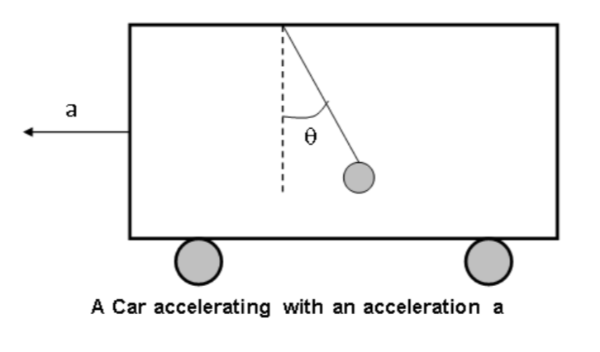

A basic accelerometer, where from inside the ball appears to feel a backward force identical to the forwards force on the car.

### Einstein’s Postulates

1. That the Laws of Physics are constant in all inertial reference frames
2. That the Speed of Light is constant in all inertial reference frames (this is also a consequence of postulate 1)

#### 1) The Laws of Physics

Although this may seem like a trivial assumption, there was also a large amount of evidence that it is impossible to tell the difference between inertial reference frames (or in other words there is no experiment that can be done in an inertial reference frame to determine whether you are moving).

Note that the Laws of Physics do change when in a non-inertial frame of reference.

#### 2) The Speed of Light

This is a consequence of Maxwell’s Equations that $c=\frac{1}{\sqrt{μ_{0}ε_{0}}}$ (where $μ_{0}$ and $ε_{0}$ are properties of the universe) . It follows that since the laws of physics (and therefore properties of the universe) remain unchanged in inertial frames, the speed of light is constant in all inertial reference frames.

### Events in Relativity

In Relativity, any event which occurs in one reference frame will occur in another reference frame (provided they are able to causally affect each other), though they may disagree about when and where they occur.

### The Lorentz Factor

The Lorentz Factor, $γ$, shows up frequently in Special Relativity and can be used to transform space-time coordinates between inertial reference frames. The Lorentz Factor is always equal to or greater than one $\left(γ≥1\right)$.

### Two things to remember

Two primary intuitions should be used when considering a special relativity problem:

1. Moving objects shrink along the direction of motion
2. Moving clocks run slow

### An Introduction to Special Relativity

To understand Special Relativity, first imagine a ball being thrown from one end of the international space station to the other, being viewed from within the space station and from Earth.  
From within the space station the ball takes some time $t_{0}$ to travel to the other end and the station has some length $l_{0}$ along its direction of motion.

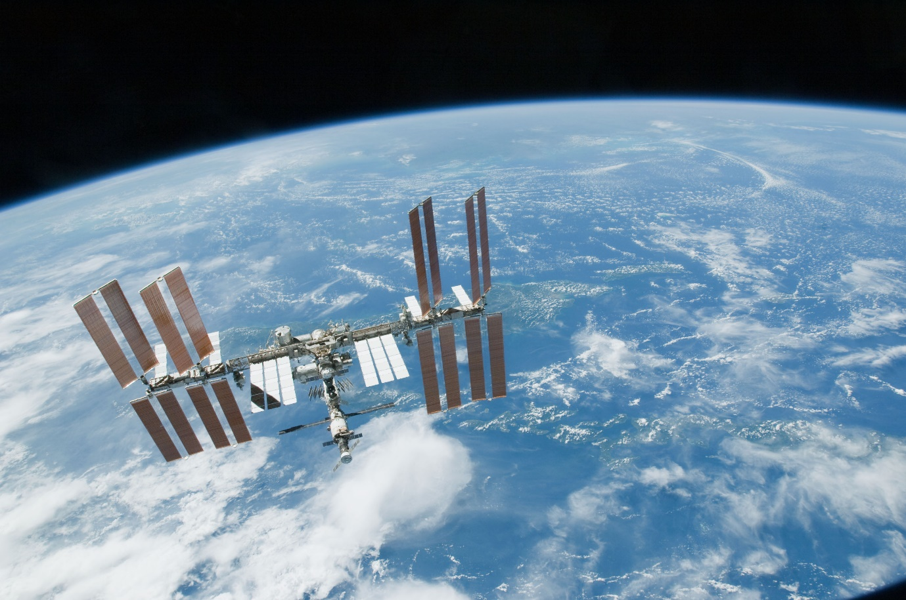

For an observer watching on Earth, they will observe the ball taking some time $t$ to reach the end of the station where the space station is of length $l$.

The rest time between the two events $t_{0}$ (the ball being thrown and the ball reaching the other end) and the rest length between the two ends of the station $l_{0}$ will be affected by the relative velocity of the space station to an observer on earth[1]:

### Time Dilation

‘A moving clock runs slow’

In the ball on the space station scenario, the time measured for the ball to reach the end of the space station will be shorter for the observer on the space station compared to the time measured by an observer on Earth. Alternatively, the observer on Earth will observe a longer time taken for a single event compared to the stationary observer.

#### Why does Time Dilation Occur? – The Photon Clock

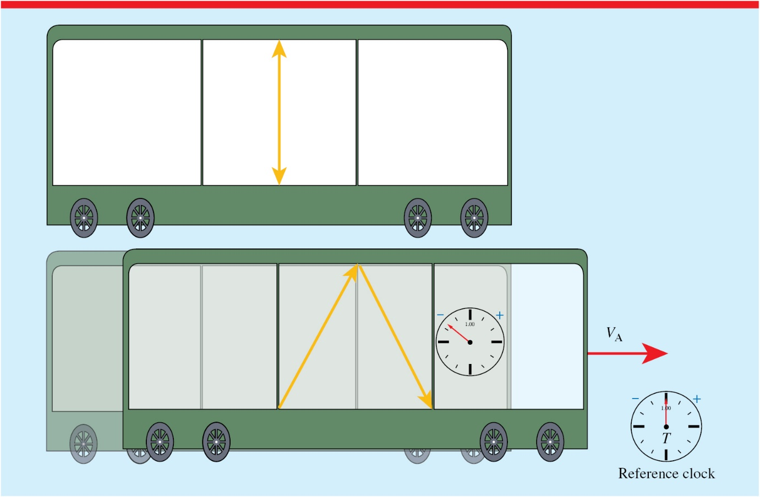Consider a situation where Jack is onboard a train moving at some fraction of the speed of light $β$, and Jill is beside the tracks on a platform. Inside the train is an evacuated vertical tube with mirrors on either end (at the top and bottom). Inside the tube is a single photon which bounces back and forth between the mirrors.

Let the distance between the two mirrors be $d$ and the time taken for the light to travel from the bottom mirror to the top mirror be $t$. As a result, $c=\frac{d}{t}$

From now on the bottom mirror shall be *Mirror A* and the top mirror is *Mirror B*. Therefore: the photon leaving Mirror A is *Event A* and the photon striking Mirror B is *Event B*.

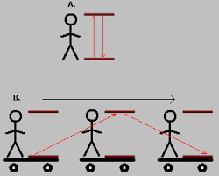Now we consider this from Jill’s perspective on the platform. While in Jack’s perspective Event A and B occur at the same horizontal coordinate, in Jill’s perspective they occur at different horizontal locations.

Jack

Jill

Jack

Jill

$$d=ct$$

$$ct$$

$$ct'$$

As can be seen in the diagram above, both Jack and Jill will observe events A and B and the distance the photon convers is $speed*time$. Since Jill observes the photon travelling a longer distance and $c$ is constant in both reference frames, Jills time ($t'$) must be longer than Jacks. In other words, Jill’s clock ticks faster than Jacks.

To calculate this by completing Jill’s diagram, using the speed of the train to calculate the horizontal distance. ($v_{train}=βc$)

Jill

$$ct$$

$$ct'$$

$$v_{train}t'$$

$${\left(ct^{'}\right)}^{2}={\left(ct\right)}^{2}+{\left(vt^{'}\right)}^{2}$$

$${\left(ct^{'}\right)}^{2}-{\left(vt^{'}\right)}^{2}={\left(ct\right)}^{2}$$

$$c^{2}t^{2}={\left(t^{'}\right)}^{2}\left(c^{2}-v^{2}\right)$$

$$t^{2}={\left(t^{'}\right)}^{2}\left(1-\frac{v^{2}}{c^{2}}\right)$$

$$t=t^{'}\sqrt{1-\frac{v^{2}}{c^{2}}}$$

$$t^{'}=\frac{t}{\sqrt{1-\frac{v^{2}}{c^{2}}}}=γt$$

Formula Sheet:

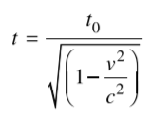

### Length Contraction

In the above scenario, the observer on Earth will observe the space station to be shorter along the axis of motion. This is because when an object moves relative to an observer, the space that object inhabits appears to shrink. In essence, all points along the direction of motion within that space get closer together.

For an observer in the moving space station, all objects in the universe appear to be moving relative to it and, therefore, will length contract. The distance between the space station and an object it is moving towards will appear to shrink and the Earth will seem thinner.

#### Why does Length Contraction Occur?

Consider a moving 1-metre ruler with some speed and an observer watching from some distance.

$$v$$

When the observer measures where the ends of the ruler are, the light rays take a different amount of time to reach the observer. The difference in time between the position measurements and the apparent simultaneity of them to the observer causes length contraction.

### The Momentum Equation and the Universal Speed Limit

The equation for momentum (which can be derived from the Lorentz Transforms) is

$${\overset{⃑}{p}}_{v}=γm_{0}\overset{⃑}{v}$$

Although it may seem like just an equation, the result of this equation is drastic.

$$γ=\frac{1}{\sqrt{1-\frac{v^{2}}{c^{2}}}}$$

As $v→c, γ→∞$

But when $v=c$

$$γ=\frac{1}{\sqrt{0}}$$

As a result, nothing in the universe with mass can travel at the speed of light as it would have undefined momentum.

### Experimental Verification for Special Relativity

Special Relativity proves a very difficult topic to verify as one must travel at a significant fraction of the speed of light for its effects to be noticeable. As a result, a precise experiment was required, capable of measuring effects to fractions of a second.

#### The Hafele-Keating Experiment - 1972

###### The story

One day Hafele (an assistance professor at the time) was sitting down writing notes on relativity when he did a ‘back of the envelope’ calculation showing that an atomic clock had enough precision to test the effects of Special and General relativity. He was unable to get the funding to do the test.

Eventually Hafele and Keating met after one of Keating’s lectures he was doing on astronomy. Keating had access to atomic clocks, and this was enough to get the pair $8000 dollars of funding, most of which went into plane tickets for the two and ‘Mr Clock’.

The experiment involved taking ‘Mr Clock’, who had been calibrated to his friend ‘Mrs Clock’ on the ground and shipping him on a long return trip plane ride. The disagreement between Mr and Mrs Clock was measured when they returned and was found to be exactly as Einstein predicted.

#### Muons from the Sun

Muons are Leptons from the standard model and are theoretically described by the associated quantum mechanics. The maximum time a muon should exist or the maximum distance it should be able to travel is given by Heisenberg’s uncertainty principle and can be shown to be too short for Muons from the sun to reach Earth. And yet we still detect them.

The reason for this can either be viewed as length contraction from the Muon’s perspective or time dilation from Earth’s perspective.

From the Muon’s perspective the distance between Earth and the Sun shrinks as it speeds up so at high enough velocities, the distance becomes shorter than the length given by the Heisenberg Uncertainty principle.

Similarly, from Earth’s perspective the Muon’s clock ticks more slowly so the time taken to reach Earth becomes shorter (for the Muon) to the point where it is shorter than the maximum lifetime of a muon.

#### Particle Accelerators

Particle accelerators provide similar evidence, with fast moving particles taking longer to decay than slower moving particles due to slower clocks.

# From the Universe to the Atom

## Base Units

Mass ($m$) – Kilograms ($kg$)

Displacement ($\overset{⃑}{s}$) – Metres ($m$)

Time ($t$) – Seconds ($s$)

Speed ($v$) – Metres per second ( $ms^{-1}$**or $m/s$**)

Momentum ($p$) – Kilogram metres per second ( $kg ms^{-1}$**or $kg m/s$** )

Wavelength ($λ$) – Metres ($m$)

Frequency ($f$) – Hertz ( $Hz$**or $s^{-1}$** )

Energy ($E$) – Joules ($J$**or $kg m^{2} s^{-2}$**  )

Luminosity ($L$) – Power ($J s^{-1}$)

Intensity ($I$) – Power per area ( $J m^{-2} s^{-1}$**or $kg s^{-3}$**  )

Angular Momentum ($L$) – Kilogram square-metres per second ($kg m^{2} s^{-1}$)

## Constants

The Speed of Light $c=3.00×{10}^{8} m s^{-1}$  
Planck Constant $h=6.626×{10}^{-34} kg m^{2} s^{-1}$

Rydberg Constant (Hydrogen) $R=1.097×{10}^{7} m^{-1}$

Wein’s Displacement Constant

## Equations

$$λ=\frac{h}{p}=\frac{h}{mv}$$

*The de Broglie wavelength of an object with mass.*

$$\frac{1}{λ}=R\left(\frac{1}{{n_{f}}^{2}}-\frac{1}{{n_{i}}^{2}}\right)$$

*Rydberg equation for the wavelength of a photon ejected or absorbed by a hydrogen atom.*

*The rest energy of an object with mass.*

$$E=mc^{2}$$

$$N_{t}=N_{0}{\left(\frac{1}{2}\right)}^{\frac{t}{t_{0.5}}}=N_{0}e^{-λt}$$

$$λ=\frac{\log_{e}{2}}{t_{0.5}}$$

*The Nuclear decay equations.*

$$ℏ=\frac{h}{2π}$$

*Another notation/form of the Plank Constant (it shows up a lot).*

$$L=mr^{2}ω=mvr=\frac{nh}{2π}$$

$$mvr=nℏ, ℏ=\frac{h}{2π}$$

*Bohr’s postulate that Angular Momentum is quantised.*

## Extension Equations

*Hubble’s Law (though the Hubble constant $\left(H_{0}\right)$ has been shown to be different at different distances.*

*‘’*

$$\frac{v}{D}=H_{0}$$

$$L=σAT^{4}, σ=5.7×{10}^{-8} W m^{-2} T^{-4}$$

*Stefan-Boltzmann Law for stars.*

$$E=γmc^{2}$$

*The total Energy, including kinetic, of an object or particle with mass.*

$$E_{k}=γmc^{2}-mc^{2}=mc^{2}\left(γ-1\right)$$

*Relativistic kinetic energy of a particle or object with mass.*

$$-\frac{ℏ^{2}}{2m}∇^{2}Ψ+VΨ=iℏ\frac{∂Ψ}{∂t}$$

*The General form for Schrödinger’s Wave Equation. $ℏ$ is a constant, $i^{2}=-1$, $m$ is the object’s mass, $∇^{2}$ is the Laplacian operator and $V$ is the potential energy as a function of time and position.*

## Course Notes

### Models of The Atom

#### Dalton – 1808

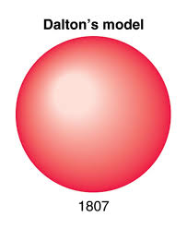Dalton expanded on the model proposed by the Greeks where he hypothesised that the Atom was made of a solid ‘billiard ball’ and was uncuttable. He explained different elements by proposing that each element had its own ball.

#### Thomson – 1904

Thomson experimented with cathode ray tubes from different materials, using electric and magnetic fields to determine its properties:

* The ray was negatively charged
* The thing which made up the ray could be forced out of any material

He was also able to balance the effects of the electric and magnetic fields to determine their charge to mass ratio but was unable to calculate either separately. In doing so he determined that the ray was made of small particles with some mass and charge.

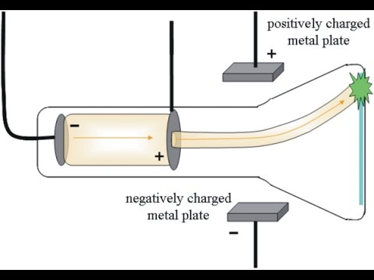From this he developed the ‘Plumb Pudding’ model which was an amendment to the Dalton model, with each atom being made of a different positively charged ball structure of uniform charge distribution and with negatively charged particles (electrons) distributed randomly throughout.

##### The Cathode Ray Experiment

The cathode ray experiment allowed the properties of what is now known as the electron to be deduced. The first setup involved:

* an electron gun (parallel plates with a hole for the accelerated electrons to pass through).
* Electric and Magnetic fields setup so they oppose and equal each other aka. a velocity selector: so named because $qvB=qE⇒v=\frac{E}{B}$

From this he deduced the velocity of the particles.

The next setup involved just using

* A magnetic field
* A detection plate

This allowed the radius of curvature given by $qvB=\frac{mv^{2}}{r}$ to be found. This allowed for the rearrangement of the above equation, using the velocity from the previous setup:

$$\frac{q}{m}=\frac{v}{Br}$$

$$=\frac{E}{B^{2}r}$$

#### Millikan Oil Drop Experiment – 1909

The oil drop experiment allowed for the determination of the charge of the electron.

Since the density $ρ$ of the oil was known, the equation $m=Vρ$ where $V$ is volume could be used to determine a given drop’s mass. When drops were injected into the apparatus, they formed spheres and since the volume of a sphere is given by $V=\frac{4}{3}πr^{3}$ and the radius of a given drop could be measured, the mass of a drop could be experimentally derived.

Millikan established an electric field such that it opposed gravity and used the equivalence of the forces and the known mass to find the charge of each drop:

$$qE=mg$$

$$q=\frac{mg}{E}$$

Millikan then noticed that the charge of each drop was always an integer multiple of $1.602×{10}^{-19}$ and noted that this must be the fundamental charge unit or the electron’s charge.

#### Rutherford – 1911

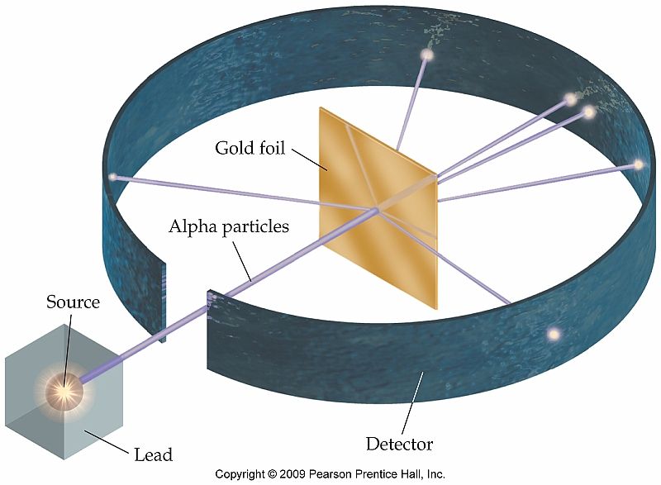Rutherford discovered, with the gold foil experiment (Geiger-Marsden), that the atom is made of mostly empty space but has a centre with an extreme density of positive charge (a nucleus). This was concluded from the fact that most of the alpha particles passed straight through the atoms, some were deflected slightly, and a few were deflected back in the direction they came from.

The fact that most particles went straight through meant that they did not come near another positive charge and experienced nearly no force. However, the fact that ones that did get deflected got deflected by a large amount implied a large charge density where the alpha particle travelled (and a large force).

#### Bohr – 1913

Bohr noted that, by Maxwell’s equations, a charge in circular motion was accelerating and would therefore create light. This light should therefore be proportional to the acceleration and would cause the electron to fall into the nucleus emitting a smooth spectrum of light. **Neither of these occur.**

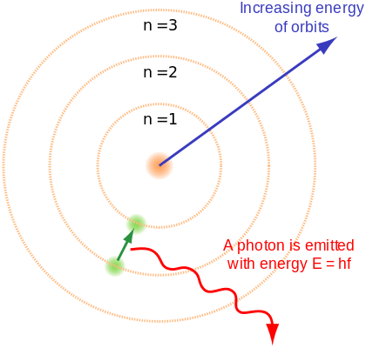Bohr then went on to develop his quantised orbital theory of electron orbits where the electrons orbited at set radii and would ‘jump’ or ‘fall’ between them. To go along with this, he formalised 3 postulates:

1. Electrons orbit around a nucleus with a high density of positive charge per volume with centripetal acceleration from the coulomb force: $\frac{1}{4πε_{0}}\frac{q_{1}q_{2}}{r^{2}}=\frac{mv^{2}}{r}$
2. Electrons orbit in a quantised number of orbitals where the angular momentum of the electrons exists in quantised states with $L=mr^{2}ω=mvr=\frac{nh}{2π}$ where $n$ is the integer orbit.
3. While in these orbits the electrons are in a ‘stationary state’, meaning they will not lose a small amount of energy as a photon and fall to some radius between the orbits.

#### Theorisation of the Proton and Neutron – 1920s

Throughout the 1920s it was discovered that the mass of atoms was approximately integer multiples of the mass of the Hydrogen nucleus and that the atomic number was proportional to the charge on the nucleus. This knowledge, combined with the discovery of isotopes (atoms with different masses but the same atomic number), led to the theorisation of the Proton and Neutron (believed to have the same mass).

#### De Broglie – 1924

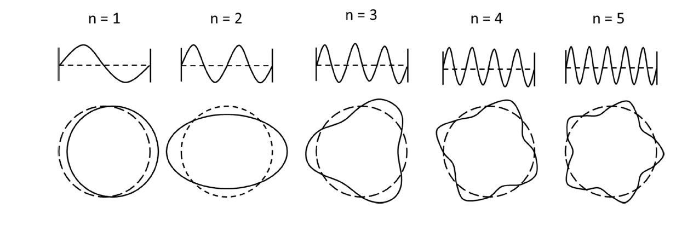He explained Bohr’s model by proposing that the electron could be a wave and a particle (invoking Einstein’s wave-particle duality theory). De Broglie postulated that if the electron were a wave then it would reason that it would have an integer number of wavelengths. This explained why the electron only existed at certain radii, as these were the radii where the electron could inhabit an orbit where the circumference is an integer multiple of the wavelength.

See <https://www.desmos.com/calculator/xww8n1r3kt> for a de Broglie wave generator.

#### Schrödinger – 1926

Schrödinger took de Broglie’s proposed wave theory and generalised it for all fundamental particles (particles which exhibit wave properties). He invented the wave function which stores all properties about that particle including its position, momentum, energy etc. This wave function however represents the probabilities of each of these properties being a certain value, not the values themselves.

Schrodinger’s Wave Equation is written in general form, where $Ψ$ is the wave function:

$$-\frac{ℏ^{2}}{2m}∇^{2}Ψ+VΨ=iℏ\frac{∂Ψ}{∂t}$$

$V$ is the sum of all potentials on the particle (has units of energy) $m$ is its mass, $∇^{2}$ is the Laplacian, $ℏ=\frac{h}{2π}$ and $i^{2}=-1$

This theory is currently the accepted theory of subatomic particles.

##### But isn’t wave motion accelerated motion?

Yes, wave oscillation is a form of acceleration. It wasn’t until a year or so after Schrödinger published his equation that people began to realise that the thing doing the ‘waving’ was in fact probabilities, not the particle. As such, Bohr’s ‘stationary state’ idea is correct (just not in the way he thought).

#### Chadwick – 1932

He found the first experimental evidence for the Neutron (in essence he discovered it, though he did not theorise it).

Neutrons had been theorised for a long time and theoretical physicists had just kind of accepted they existed. They provided a great explanation for why the mass of particles on the periodic table increased at a greater rate than their charge.

##### The Neutron Experiment

Alpha particles were emitted onto a Beryllium plate. A sheet of paraffin wax was then placed after the Beryllium and a charge detector detected what were found to be protons being emitted from the wax. However, the charge detector did not detect anything when placed between the beryllium and wax.

By putting a thick lead plate between the beryllium and the wax, the release of protons from the wax was stopped. Using this, Chadwick reasoned that there must be some neutral charge being emitted from the beryllium.

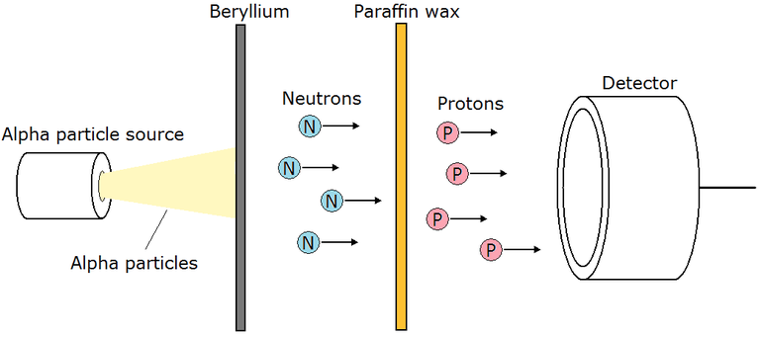Using conservation of mass and momentum, Chadwick determined the ratio of the neutral particles mass to the proton and found that the masses were almost identical (the neutral particle was just 0.1% heavier). This allowed Chadwick to conclude that he had found the theorised Neutron.

### The Standard Model

#### Terminology

**Quark** – A particle which, among other properties, possesses a colour charge (red, green or blue). As a result, they interact with Gluons and are affected by the strong interaction.

**Lepton** – A particle which does not interact via the strong interaction (i.e. it has no colour charge)

**Boson** – A particle responsible for force interactions.

**Virtual Particle** – A particle which is not directly observable but can still interact with other particles.

**Hadrons** – Particles made of two or more quarks with integer charges.

**Baryons** – Particles made of three quarks

**Anti**-**Matter** – A particle which is the complete opposite of another (opposite electric charge, opposite colour charge etc.)

**Annihilation** – Occurs when a particle collides with its anti-particle. The process creates an immense amount of energy in the form of photons.

**Fundamental Forces** – The minimum number of forces required to describe all phenomena in the universe (Strong, Weak, Electromagnetic, Gravity)

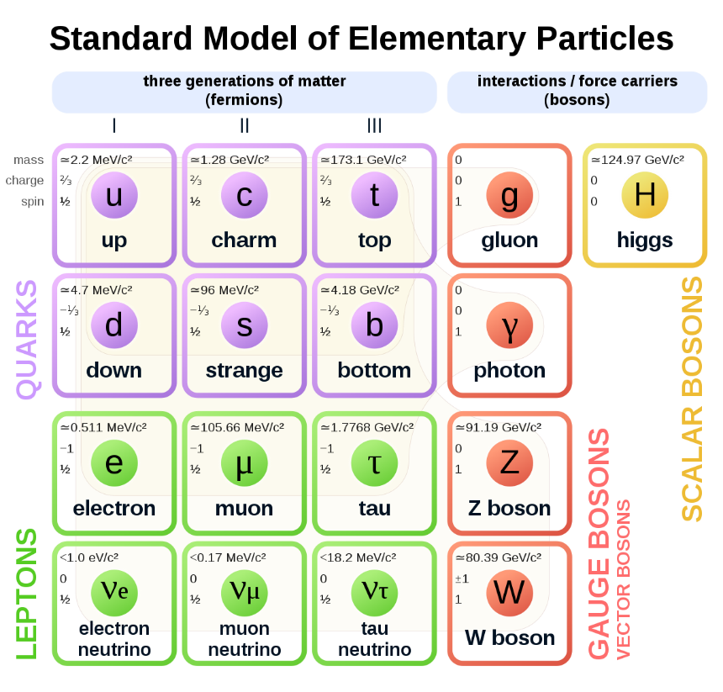

#### What is the Standard Model?

The standard model is the current model of particle physics which has been experimentally verified.

The standard model consists of fundamental particles with certain properties such as charge, mass etc.

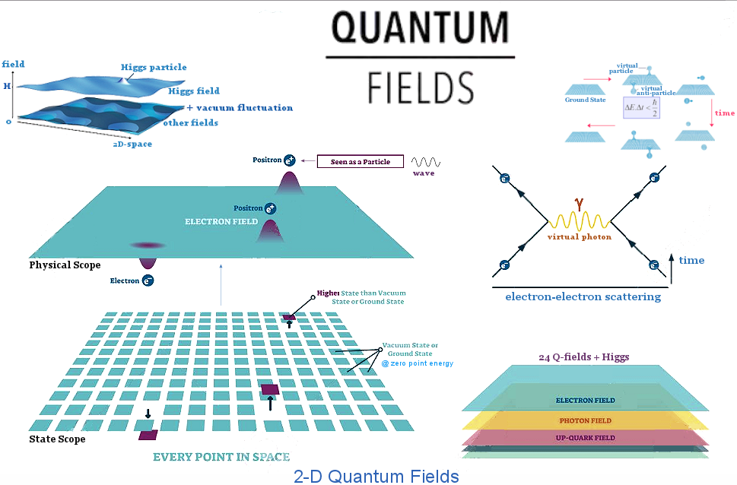Each of these fundamental particles is a little wiggle (wave) in its respective field (e.g. the electron is a small disturbance in the electron field). The reason particles have certain properties is a function of how much one field affects another field.

#### Anti-Particles

Anti-particles such as the anti-electron (positron) come up a lot in quantum physics. Although they have been observed in experiment, they were first predicted by Dirac when he was formulating his equation for the electron, where he found his equations always had two solutions. His two solutions consisted of opposite energies and opposite charges and he interpreted this as being a particle and its anti-particle.

Although the maths he performed was a little more complex, a basic understanding of this can be gleaned from the energy equation:

$$E^{2}={m_{0}}^{2}c^{4}+p^{2}c^{2}$$

If we assume the velocity and momentum are zero, we find $E^{2}=m^{2}c^{4}$

This does not rearrange to $E=mc^{2}$, rather it rearranges to $E=±mc^{2}$ and the negative solution is what Dirac interpreted as the anti-particle.

#### What does $E=mc^{2}$ mean?

When Einstein wrote his paper, he showed that due to special relativity an object which loses some kinetic energy $E$ lost mass $Δm=\frac{ΔE}{c^{2}}$

Although it is written as $E=mc^{2}$ it should actually written $m=\frac{E}{c^{2}}$  
What this shows is that mass is actually just a way we measure the net energy content of an object. The inherent mass an object has actually comes from the energy the Higgs field gives the particles it is made of. Furthermore, mass is not a real property, rather it is a manifestation of energy and is how we measure it.

Go watch this video for a good explanation:

[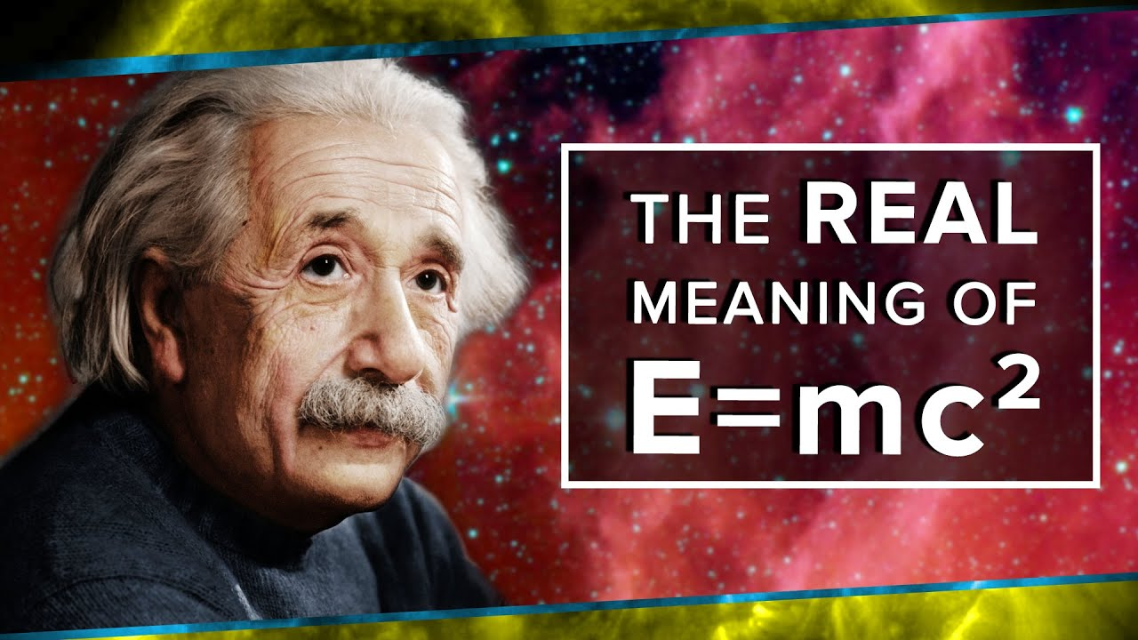](https://youtu.be/Xo232kyTsO0)

<https://youtu.be/Xo232kyTsO0>

#### Conservation Laws

All conservation laws are due to invariances in some value. Where there is an invariance in some value during an interaction, some value is conserved (some are given below).

###### Conservation of Charge

In any interaction where there is Gauge symmetry, the total charge of the universe must be conserved where:

$$\left(+1\right)+\left(-1\right)=0$$

###### Conservation of Colour

In any interaction, the total colour charge must be conserved where:

$$\left(B\right)+\left(G\right)+\left(R\right)=0$$

$$\left(B\right)+\overline{B}=0$$

###### Conservation of Momentum

In all interactions where there is translational symmetry (location of the event occurred does not change the interaction between the particles), momentum must be conserved.

###### Conservation of Angular Momentum (Spin)

In all interactions where there is rotational symmetry (the event would be the same if space were rotated), intrinsic angular momentum is conserved.

###### Conservation of Lepton Number

This is empirical and has never not been observed. This is an additive law where normal leptons such as electrons $\left(e^{-}\right)$ and electron neutrinos $\left(ν_{e}\right)$ have $+1$ lepton number and their anti-particles such as the positron $\left(e^{+}\right)$ and anti-neutrino $\left({\overline{ν}}_{e}\right)$ have a lepton number of $-1$.

#### The LHC and other Evidence for the Standard Model

The LHC collides protons and other Hadrons together at very high speeds $\left(0.999 999 99c\right)$.

The protons slam together at such high energies that they break apart and their constituent particles decay into lower energy particles.

The particles produced are random (to an extent) so they slam protons together many millions of times per second. They produce too much data to store so most of it is thrown out and only the possibly interesting ones are stored.

The detectors at the LHC are able to detect certain types of particles depending on the detector (there are 4 main detectors). The detected particles and their energies can then be used to reverse engineer the collision which occurred, and it has been shown that the collisions match what would be expected from protons made of three quarks colliding.

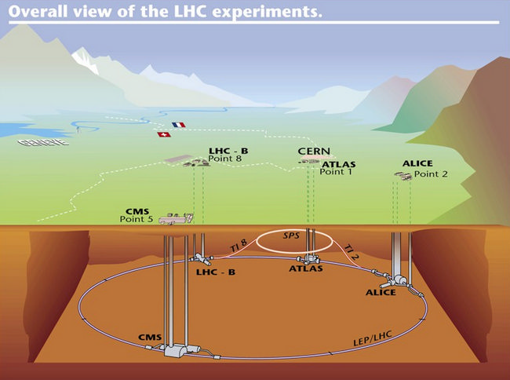

#### Quarks, Gluons & Colour Charge

Gluons and Quarks possess a property called colour charge (it is not colourful but there are three types instead of two so physicists needed something more than $+ -$) the colours are Red, Green and Blue (with a corresponding Anti-Red, Anti-Green and Anti-Blue for anti-particles). The charges are named as such since red + green + blue = white, so the charges cancel in sets of three. The study of these charges and the corresponding interactions is called Quantum Chromodynamics.

The ‘flavour’ of a quark is its classification (i.e. Up, Down, Charm, Strange etc.).

Though Quarks possess electric charge, the primary force which bonds them is mediated by their colour charge and the force particle corresponding to it: the gluon.

The gluon has no mass or electric charge, but it does have a colour charge and an anti-colour charge (never the same like blue and anti-blue though) and so it is one of the few particles which can interact with quarks without interacting with other particles.

Quarks are held together by flux tubes of gluons which attract the quarks together. The main property of these flux tubes that differs from lone gluons is that the colour charge of the gluons in the flux tubes cancel to be zero, keeping the net colour charge of the proton and neutron zero.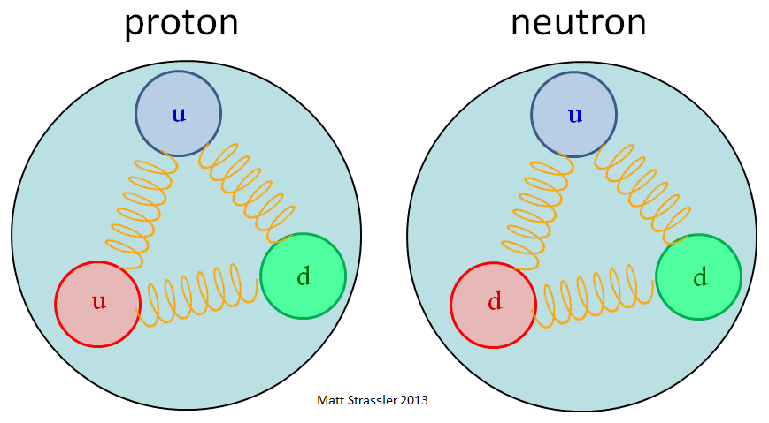

The analogy of springs is used for the flux tubes since the attractive force created by the gluons increases with the distance of the particles as with a spring.

### Nuclear Physics

#### Terminology

**Bonding Energy** – The potential energy in the bond such that:

$$E_{bond}=-U$$

$$F_{bond}=-∇U=-\frac{dU}{dr}\hat{r}$$

**Atomic Mass Unit $\left(u\right)$**  – The average mass of the nucleons in a Carbon 12 nucleus such that:

$$u=\frac{m_{C-12}}{12}$$

**Decay** – The process by which one particle becomes another particle by emitting another particle.

**Nucleon** – A proton or neutron.

**Half Life** – The time a sample of some material takes to transmute into another material.

**Control Rod** – A material used to absorb neutrons in a nuclear reaction.

**LHC** – The Large Hadron Collider located under Switzerland and run by CERN.

#### Decay

Nuclear decay is a random (but statistically predictable) process whereby energetically unstable nuclei decay into more stable nuclei and release certain particles such that:

* Charge is conserved
* Energy is conserved
$U+E_{K}$

* Momentum is conserved

##### Alpha $\left(α\right)$ Decay

Alpha decay is a result of the strong force between neighbouring nucleons being weaker than the electrostatic repulsion of the protons. The exact mechanism is hard to explain but fundamentally it is when the potential energy binding an alpha particle $\left(α or {}_{2}^{4}{He}\right)$ to the nucleus is near zero. There is still a large potential bond between neighbouring nucleons (due to the strong interaction) however the chunk is only loosely held so it is ejected.

The leftover potential energy is lost as a photon and can be measured as a loss in mass.

The nuclear equation can be written as:

$${}_{Z}^{A}X→{}_{Z-2}^{A-4}Y+{}_{2}^{4}{He}+{}_{0}^{0}γ$$

Or

$${}_{Z}^{A}X→{}_{Z-2}^{A-4}Y+{}_{2}^{4}α+{}_{0}^{0}γ$$

##### Beta $\left(β\right)$ Decay

Beta decay occurs in two forms

$β^{-}$

$β^{+}$

$β^{-}$ decay is where a neutron becomes a proton through the weak interaction and, by conservation of charge, an electron is released. During this process, an anti-neutrino is also given off.

$${}_{Z}^{A}X→{}_{Z+1}^{A}Y+{}_{-1}^{0}{e^{-}}+{}_{0}^{0}{{\overline{ν}}_{e}}+{}_{0}^{0}γ$$

$β^{+}$ decay is where a proton becomes a neutron through the weak interaction and, by conservation of charge, a positron is released. During this process, a neutrino is also given off.

$${}_{Z}^{A}X→{}_{Z-1}^{A}Y+{}_{1}^{0}{e^{-}}+{}_{0}^{0}{ν_{e}}+{}_{0}^{0}γ$$

The potential energy lost by this transmutation is the emitted as a photon.

###### Why neutrinos are emitted

Neutrinos are emitted in these interactions to conserve spin and lepton number. The neutrino conserves spin because it spins the opposite way to the electron (is spin down if the electron is spin up) making the net spin zero.

Neutrinos and electrons have lepton numbers of $+1$ while anti-neutrinos and positrons have lepton numbers of $-1$. The total sum of the products must equal the initial (which was zero).

##### Gamma $\left(γ\right)$ Emission

Gamma emission is the emission of a photon (typically in the gamma spectrum but could be in any spectrum) and occurs due to a loss of potential energy (also known as an increase in binding energy_ inside the nucleus. This can occur during any type of radioactive decay and is a result of protons and neutrons swapping places inside the nucleus (a process which is made possible due to the nuclear force interaction).   
When the protons move, they move in the direction such that their potential energy decreases. So, by conservation of energy, this energy must be regained. In this case it occurs as a photon.

This can occur during all types of radioactive decay but typically occurs during $β$ decay.

#### Penetrating Distance and Ionisation

Different forms of radiation are able to penetrate materials to varying distances. Generally, the further radiation can penetrate, the lower its ionisation potential. This is not true when comparing gamma radiation to X-rays as gamma rays possess both a greater penetration distance and ionisation energy.

$α$ particles are most likely to cause ionisation as they strongly attract electrons that they are near to.

$β^{-}$ (electrons) cause ionisation because they collide with the electrons in outer shells of atoms, transferring momentum and knocking the electron off.

$β^{+}$ (positrons) cause ionisation because they annihilate electrons in a collision.

$γ$ rays have much greater energies ($E=hf$) than is required to ionise an atom and so, on collision with an electron, transfer their energy to the electron as kinetic energy, ionising the atom.

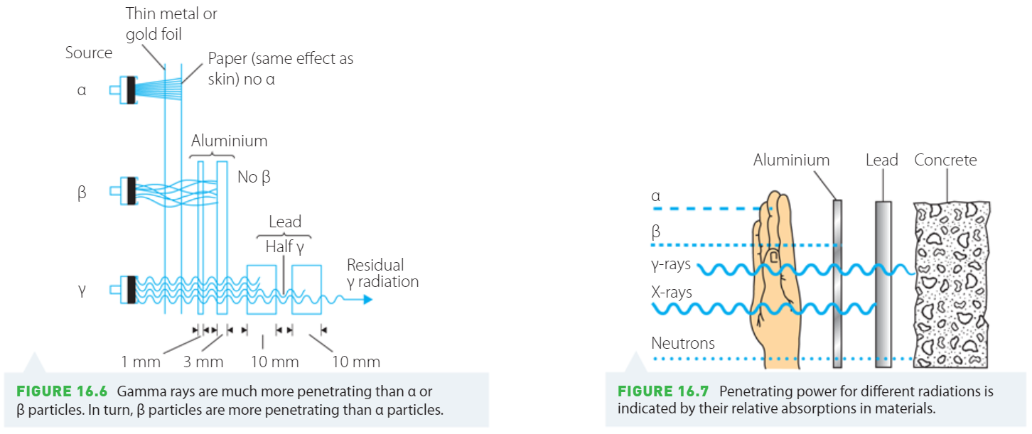

#### Half Life

Half Life describes the statistical nature of nuclear decay in one easy concept. All unstable nuclei (prone to either form of decay) will have some time after which half of a large sample will have decayed.

Since after every integer multiple of the half life time $\left(t_{0.5}\right)$ the sample has halved in size, we can write that mathematically where $N_{t}$ is the amount after some time and $N_{0}$ is the original amount:

$$N_{t}=N_{0}{\left(\frac{1}{2}\right)}^{\frac{t}{t_{0.5}}}$$

It is easy to see when $t=t_{0.5}, N_{t}=\frac{N_{0}}{2}$ and when $t=2t_{0.5}, N_{t}=\frac{N_{0}}{4}$ etc.

Now we rearrange because the formula sheet is unnecessarily specific…

$$N_{t}=N_{0}e^{\ln\left({\left(\frac{1}{2}\right)}^{\frac{t}{t_{0.5}}}\right)}$$

$$N_{t}=N_{0}e^{\frac{t}{t_{0.5}} \ln\left(\frac{1}{2}\right)}$$

$$N_{t}=N_{0}e^{\frac{-t}{t_{0.5}} \ln\left(2\right)}$$

$$N_{t}=N_{0}e^{-t \frac{\ln\left(2\right)}{t_{0.5}} }$$

Now we let $\frac{\ln\left(2\right)}{t_{0.5}}=λ$

$$N_{t}=N_{0}e^{-λt }$$

$$λ=\frac{\ln\left(2\right)}{t_{0.5}}$$

#### Fission

Fission is the process by which a nucleus is split into two smaller parts. Typically, this is done with heavy nuclei such as Uranium-235 $\left({}_{92}^{235}U\right)$ whereby the atom is made unstable by shooting low velocity neutrons at it and it splits into two parts, one a little heavier than the other. As a result of this, neutrons are also released. E.g.

$${}_{0}^{1}n+{}_{92}^{235}U→{}_{36}^{92}{Kr}+{}_{56}^{141}{Ba}+3{}_{0}^{1}n$$

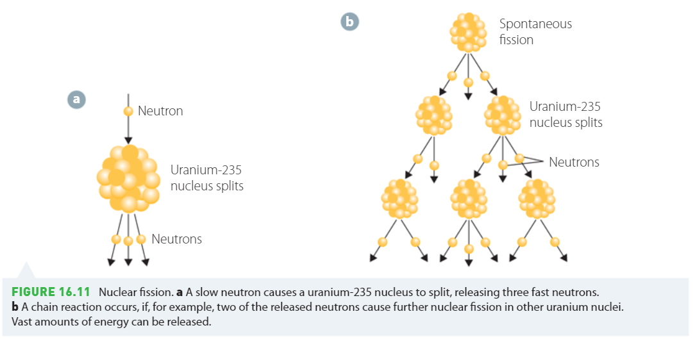

A nuclear reaction such as that in a bomb occurs when more neutrons are produced per second than reactions are occurring (i.e. more than one neutron is produced per fission on average), this is a runaway reaction.

A nuclear reaction such as ones used in nuclear reactors is one where the number of neutrons produced per reaction is less than or approximately one, so it is ‘controlled’.

##### The Moderator

This is made of a material with a slightly higher mass than the neutron such as Hydrogen $\left({}_{1}^{1}H\right)$, Deuterium $\left({}_{1}^{2}H\right)$ or Tritium $\left({}_{1}^{3}H\right)$. The neutrons collide with these atoms and share their energy. This slows down the neutron so that it can be absorbed for more reactions.

##### Control Rods

If a reaction such as one in a nuclear reactor begins producing more neutrons than desired, control rods are inserted. Control rods are made of materials such as boron which more freely absorb neutrons (known as neutron poisons).

##### Enrichment

Since Uranium-235 is one of the few very reactive substances for nuclear reactions, it often needs to be separated out from the less reactive Uranium isotopes if a faster reaction is desired (the concentration of Uranium-235 required for a nuclear bomb is around 97%). Other Uranium isotopes can even absorb neutrons without reacting as they are more stable.

#### Fusion

Fusion is the process by which protons and neutrons are brought together with enough energy that they overcome their electric repulsion and are able to bond via the strong force. In the sun this is done by the pressure of gravity (and with a little help from quantum tunnelling) and in fusion reactors it occurs by colliding particles with enough kinetic energy that they bond but not so much that they obliterate each other.

Below is a graph of overall binding energies of nuclei.

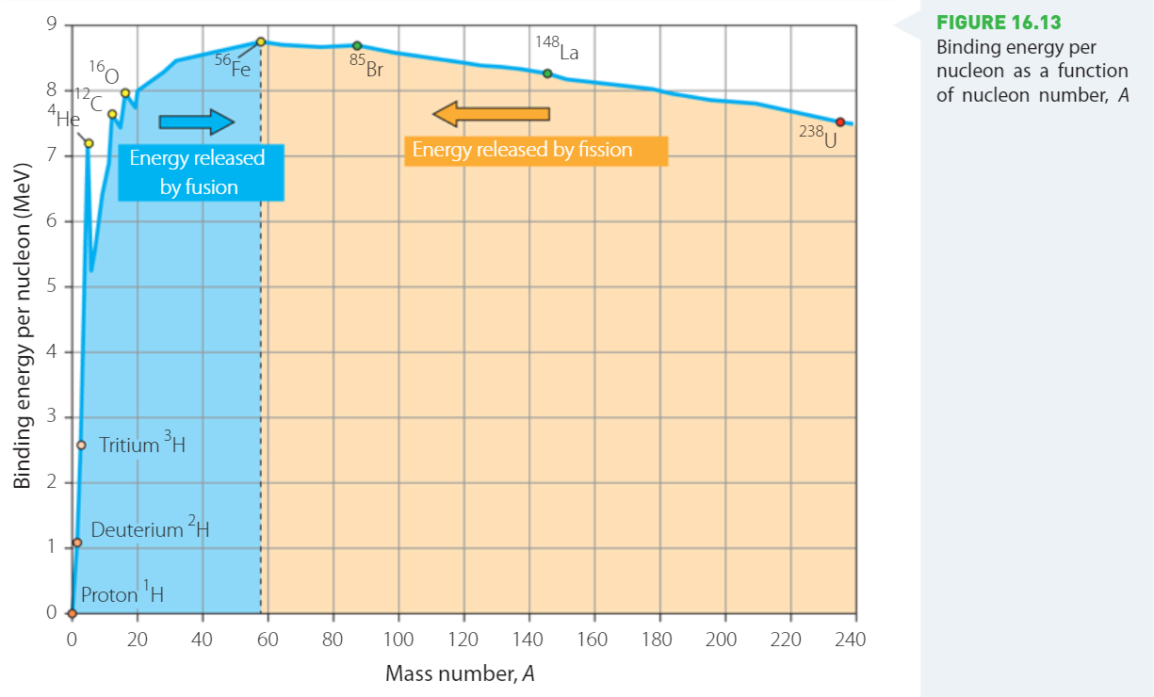

##### Getting Energy from Fusion

Remembering that in actuality, the bonding energy is the negative potential energy, an increase in bonding energy is a net decrease in energy:

As atoms before iron are bonded, the net energy inside the nucleus decreases. By conservation of energy, an equivalent amount of energy must be released. The released energy is given by $E=-∆U$ (the change in energy between the particles). If $E$ is negative, then extra energy is needed to bond them.

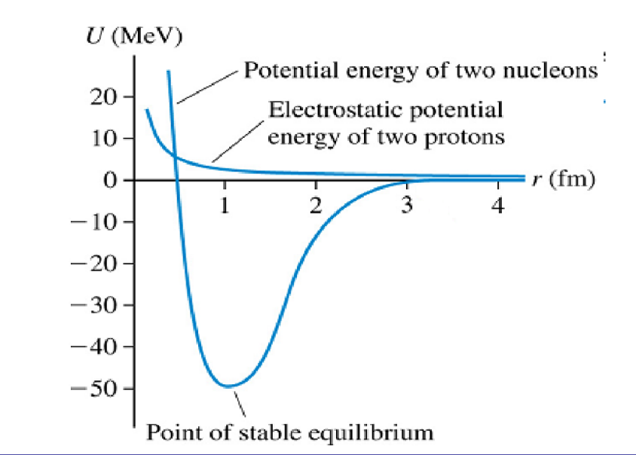

The attractive strong force appears at close ranges and makes the potential energy negative while the electric potential remains positive.

##### Forces, Energies and Emitted Particles

As a general rule, attractive forces produce negative potentials and repulsive forces produce positive potentials. When the net energy between particles decreases (bonding energy increases) there has been an increase in strength of the attractive force and vice versa.

When the energy between two quantum particles decreases, the energy must be emitted. The energy is often emitted as a photon. Sometimes, a particle can acquire a lower energy state (greater attractive force) by transmuting into another particle (like proton to neutron) and if this occurs, conservation of charge dictates that the equivalent charge must be emitted. Therefore, a positron and anti-neutrino will be released in such process such that they carry away the energy and charge.

##### Mass Defect in Stars

It is often said that stars lose mass when they fuse matter, and that this mass is lost as energy in the form of photons. This is not entirely correct; it is more accurate to say that when we measure mass, we are measuring the net energy content of stars. So, when stars lose energy, their observed mass drops but the particles which make it up do not lose mass, we are just observing the loss of energy in a strange way.

Really, we are saying that $m=\frac{E}{c^{2}}$ and as $E$ decreases, the apparent mass decreases.

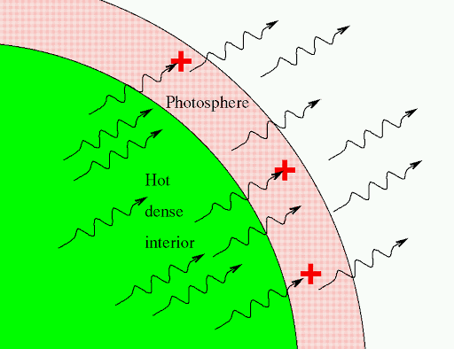

##### Fusion Inside a Star – Hydrogen to Helium and the CNO Cycle

###### Proton-Proton Fusion – 26.73 MeV

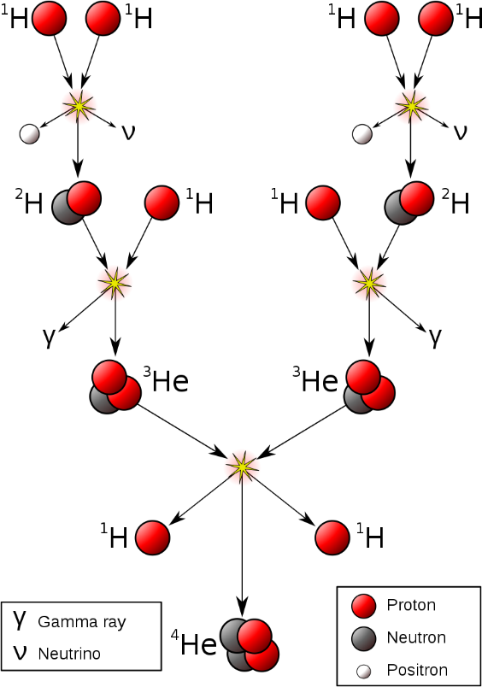Here’s how helium can be made in the sun from 4 protons.

$${}_{1}^{1}H+{}_{1}^{1}H→{}_{1}^{2}H+{}_{1}^{0}{e^{+}}+{}_{0}^{0}{ν_{e}}$$

$${}_{1}^{2}H+{}_{1}^{1}H→{}_{2}^{3}{He}+{}_{0}^{0}γ$$

$${}_{2}^{3}{He}+{}_{2}^{3}{He}→{}_{2}^{4}{He}+2{}_{1}^{1}H$$

###### The CNO Cycle – 25 MeV

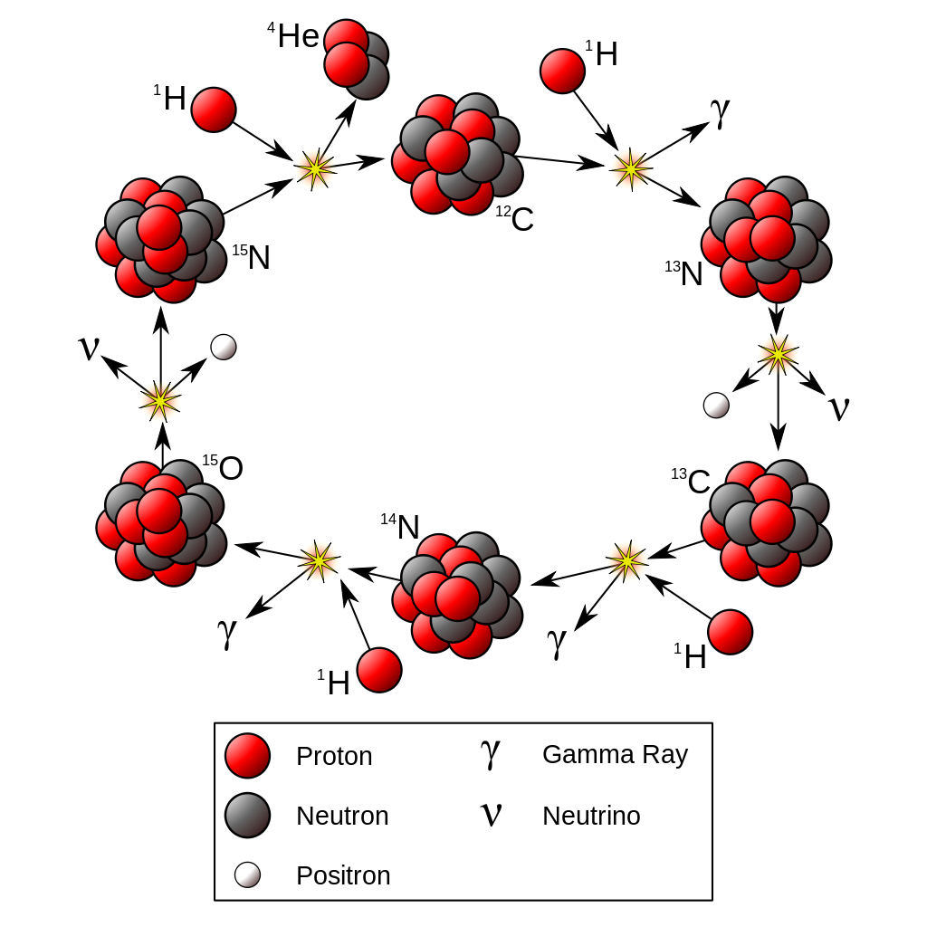The CNO cycle is another way that stars take 4 protons and make a helium nucleus.

$${}_{6}^{12}C+{}_{1}^{1}H→{}_{7}^{13}N+{}_{0}^{0}γ$$

$${}_{7}^{13}N→{}_{6}^{13}C+{}_{1}^{0}{e^{+}}+{}_{0}^{0}{ν_{e}}$$

$${}_{6}^{13}C+{}_{1}^{1}H→{}_{7}^{14}N+{}_{0}^{0}γ$$

$${}_{7}^{14}N+{}_{1}^{1}H→{}_{8}^{15}O+{}_{0}^{0}γ$$

$${}_{8}^{15}O→{}_{7}^{15}N+{}_{1}^{0}{e^{+}}+{}_{0}^{0}{ν_{e}}$$

$${}_{7}^{15}N+{}_{1}^{1}H→{}_{6}^{12}C+{}_{2}^{4}{He}$$

###### Triple Alpha Fusion – 7.725 MeV

Triple $α$ fusion occurs in old, post main series stars.

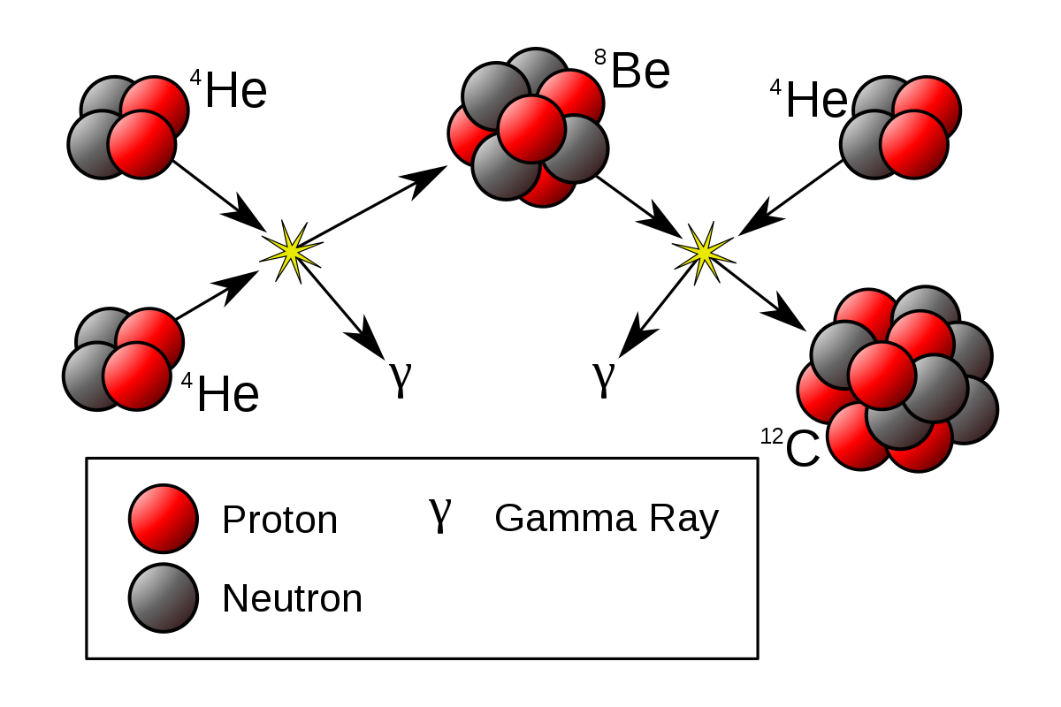 ${}_{2}^{4}{He}+{}_{2}^{4}{He}→{}_{4}^{8}{Be}+{}_{0}^{0}γ$

$${}_{4}^{8}{Be}+{}_{2}^{4}{He}→{}_{6}^{12}C+{}_{0}^{0}γ$$

#### Spectral Classes

Different stars fuse different types of nuclei and, as a result, have certain properties.

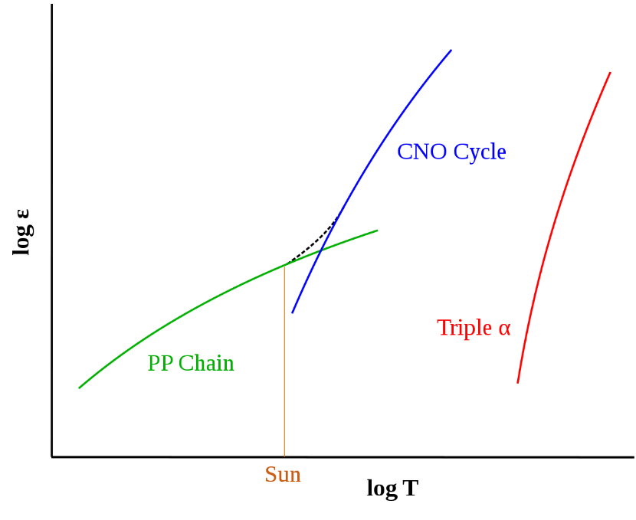

Temperature

energy

PP Chain gives the most energy per reaction but requires a greater amount of gravitational attraction which can only be achieved after the star has made heavier elements. As a result, small stars fuse using PP chain and then hotter stars fuse lots of nuclei using CNO as it is easier to do (particles have more mass so easier to get high momentum collisions).

Big stars with lots of mass and not as much fuel burn using triple $α$.

#### Star spectra and what it says about a star

Stars emit light due to Blackbody radiation at their surface. Stars generate the energy to heat up the surface through fusion, however fusion itself does not create light.

The blackbody spectrum is continuous, with a peak in the spectrum occurring at $λ_{max}=\frac{b}{T}$. Gaps appear in the spectrum due to the atoms in the upper atmosphere of the star which absorb photons which hit them at certain wavelengths. The atoms then re-emit this energy as photons (not necessarily the same photon) but in a random direction. The result is that light of the wavelengths where it can be absorbed by the atmosphere of the star are much dimmer than the rest of the blackbody spectrum of the star. This is the star’s absorption spectra.

##### What can it the absorption spectra tell us?

###### Temperature

The brightest part of the spectrum tells us the temperature.

###### Atmospheric Elements

By comparing the shape and position of the spectral lines to known elements on Earth, we can determine what elements are in the atmosphere of the star (it is rare that elements have the same absorption line, so it is easy to guess and check elements).

###### Density

The density of the star’s atmosphere is a result of the star’s density because more dense stars have a greater gravitational attraction and therefore hold a denser atmosphere. A denser atmosphere will result in darker absorption lines (more stuff to absorb photons).

###### Rotational and Translational Velocity

The velocity of points on a star will result in a Doppler effect. If a star is rotating, one side of the star will redshift the spectrum and one will blueshift it. This can be measured and used to calculate the rotational velocity.

Translational velocity is similar but instead we compare the theoretical colour of the star based on its temperature to its apparent colour (still a Doppler effect).

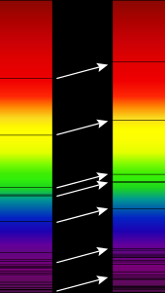

### The Big Bang and the Origins of the Elements

The Big Bang theory originates from General Relativity, where the solution to Einstein’s equations shows that the universe must have a beginning.

The Big Bang Theory is the currently accepted theory that the universe began as infinitesimal point and expanded from that point. The theory describes the very expansion of space itself, that is if space is made of 4 dimensions $\left(x, y, z, ct\right)$ then these dimensions are what expanded.

This early universe was very dense in energy and so matter was able to spring out of the energy of the vacuum in the form particle anti-particle pairs. Initially, the temperature of the universe was very great, so the particles were moving too fast to combine and quickly collided with their respective anti-particles.   
It is measurable that the amount of matter produced in this process was slightly greater than antimatter, though the cause is unknown.

The energy from these collisions was initially released as gamma rays. As the universe expanded doppler shift occurred, eventually lowering the energy of the photons.

As the universe expanded, the temperature of the particles decreased, and they were able to combine to form protons and neutrons.

Although particles and anti-particles were created in equal parts, the asymmetry of the weak nuclear interaction is attributed as one of the possible reasons there is far less anti-matter in the universe today. This is still one of the great mysteries of physics and is yet to be fully modelled.

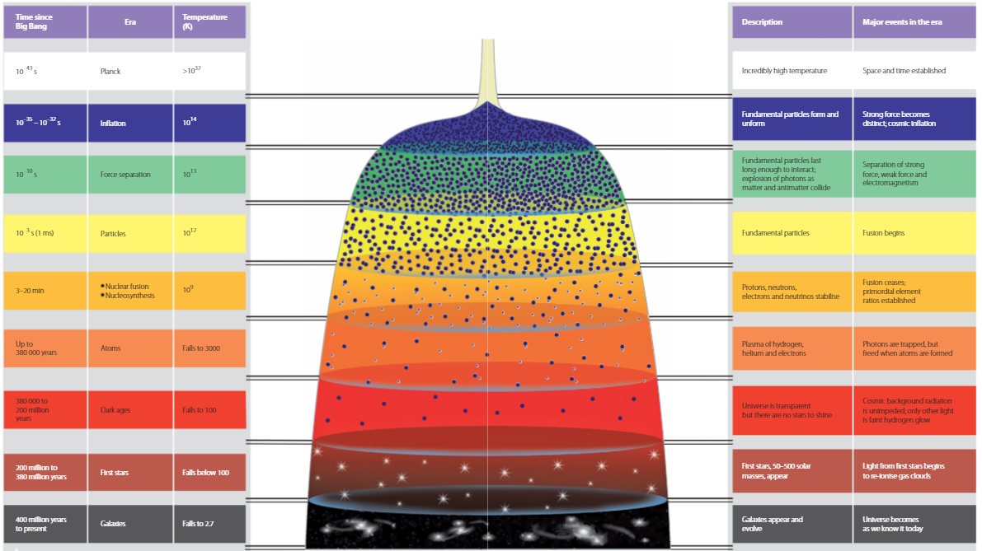

#### Timeline of the Big Bang

It is believed that, originally, Gravity; Electromagnetism; the Strong Force; and the Weak Force were all one force. It is believed that Gravity was the first to split as its own force, then the strong force, leaving the Electroweak force (the united electromagnetic and weak force which has been mathematically proven).

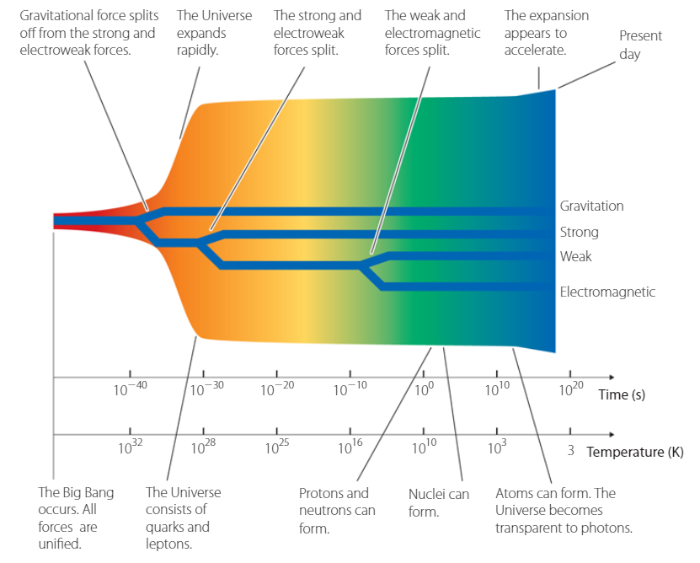This is why Physicists would like to find a theory of everything so they can finally prove or disprove the theory.

#### Inflation

This is an un-proven theory which says that if the universe underwent a brief period where space doubled 100 times then the homogeneity of the universe can be explained. There is currently no evidence for inflation, though it is widely accepted.

#### The Cosmic Microwave Background and Cosmological Redshift

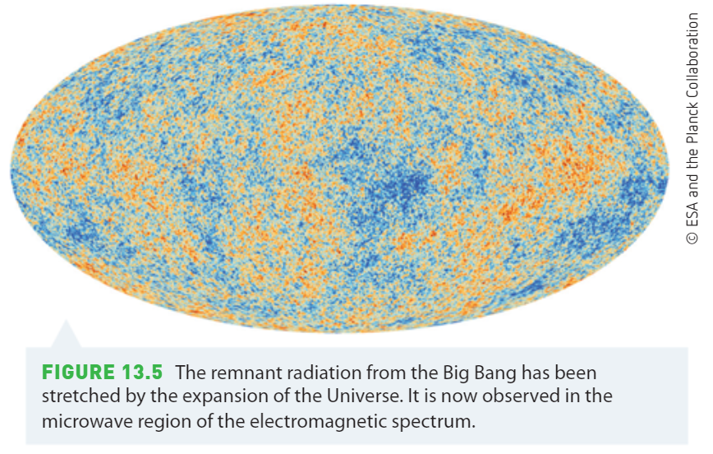Initially, large amounts of radiation was emitted due to matter anti-matter annihilation in the form of gamma rays. As the universe expanded the space taken up by the photons expanded, increasing the wavelength of the photons. This is known as cosmological redshift and is also what redshifts the light coming from distant galaxies.

#### The Hubble Constant and Spatial Expansion

Alexander Friedmann was the first to show that solutions to Einstein’s field equations had possible solutions for both an expanding and contracting universe. Einstein did not readily accept this idea but with empirical evidence, eventually admitted that Friedmann was correct (after Friedmann had died from typhoid).

Georges Lemaitre found a similar solution and used empirical astronomical data to show that the universe was expanding. Due to the fact that all points in space are expanding away from each other, objects which are further away move away at a faster speed (since there is more points in space moving away from each other). Using the solution that the universe is expanding at a constant rate, Lemaitre concluded that $\frac{v}{D}=constant$.

Hubble was able to later use empirical evidence to show this relationship and measure the constant. We now call this relationship Hubble’s Law $\frac{v}{D}=H_{0}$ where $H_{0}$ is Hubble’s constant.

In reality the Hubble constant changes with distance, showing an accelerating speed of expansion.

#### Proof for Spatial Expansion

The evidence for this expansion is the emission spectra of stars, where spectral lines of similar stars are shifted, and the further the star is, the more it is shifted.

##### Absorption Spectra as described by Atomic Theory

The absorption spectrum of a star is given by the gaseous particles in its atmosphere. Photons which are emitted by the star that can be absorbed by atoms in the atmosphere are absorbed by those atoms, the re-emitted later with a random direction. The result of this is that a much lower intensity of the light reaches the earth.

#### Accelerating Spatial Expansion

It was believed that the most probable solution to Einstein’s field equations was that space may be expanding, but that it was slowing down due to the negative potential energy of gravity. It turns out that it is possible (and allowed in the field equations) for the universe to have a positive energy content which would cause the universe to expand at an accelerating rate. This energy can be measured by making this assumption but is not directly predicted by any current theories.

The accelerating rate of spatial expansion was measured by a physicist at ANU. What they found was that the Hubble constant for distant supernovae increased the further away you look, showing that the velocity at which objects move away from each other changes with time and with a positive gradient (i.e. $\frac{∆v}{∆t}>0$).

For more, you can watch the video from the man himself: <https://www.youtube.com/watch?v=55pcpTjd3BY&ab_channel=ANUTV>

The mechanism for this expansion is called Dark Energy, though nothing is known about it.

##### The Hertzsprung-Russel (H-R) diagram

The colour, size and mass of a star can be associated with its temperature and luminosity.

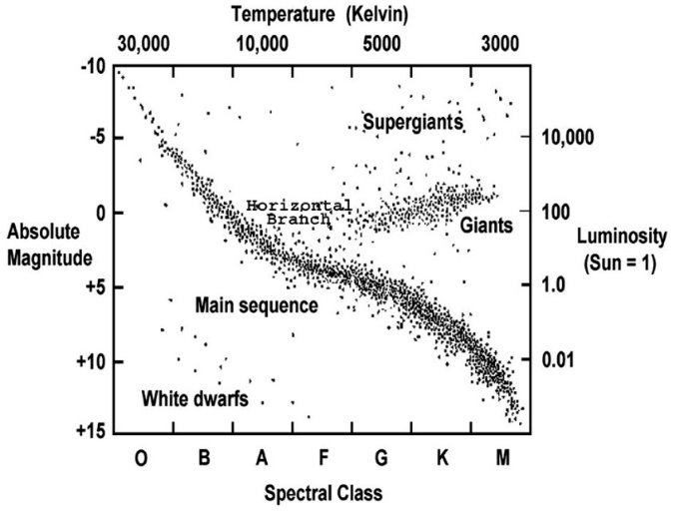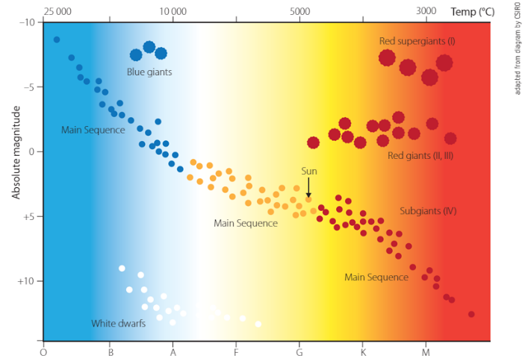

###### The Axes

* **Absolute Magnitude**: How bright the star would appear if it were 10 parsecs away (on a logarithmic scale)
* **Luminosity**: The power output of the star
* **Temperature**: The surface temperature of the star which causes blackbody radiation
* **Spectral Class**: The colour of the star defined at certain cut-off points.

High Mass stars are typically towards the top of the diagram since high mass stars can fuse more atoms per second and therefore are more luminous.

All stars emit light as a function of blackbody radiation (where the wavelength emitted depends on their surface temperature).

The red giants are giant because they are fusing lots of atoms producing a large outward pressure. However, the energy produced is spread across many layers, so the outer layer is cooler and therefore more red.

White dwarfs are the remains of the cores of stars which emit light due to blackbody radiation but no longer fuse nuclei. They have been compressed to the point where the only thing keeping them at a fixed radius is the outwards pressure of the electrons in their shells. The Pauli Exclusion Principle keeps them from compressing further so they maintain their size.

Neutron stars are white dwarfs where the gravity was so strong it allowed the electron shells to shrink and the electrons to combine with protons to make neutrons. Now the only thing keeping them apart is the pressure of the exclusion principle between the neutrons.

1. This example is not exactly accurate to reality as the space station is undergoing centripetal acceleration and is therefore in a non-inertial reference frame (i.e. we need general relativity to describe the situation). However, this example should otherwise provide a plausible situation where an object is moving at a relatively fast speed.